Flags and Maps in Art
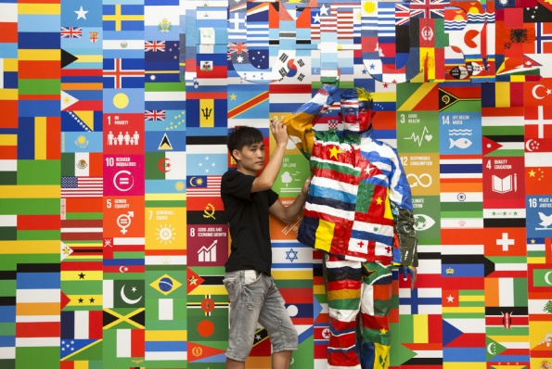
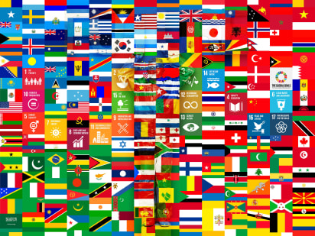
Lui Bolin – the invisible man - vanishes for UN global goals campaign
Hi Everyone,
Flags can be used as patriotic symbols, to send messages or for decorative purposes. I love looking at maps, each time I notice something new or follow a different route. They present information in a simple, visual way. Maps can teach us about size and shape, relationships between things and the features of a place, thing or idea. In the images above, Lui Bolin camouflages himself amongst the flags of the world – can you find him in the second image?
Have a look at the Lui Bolin PDF, can you spot him in each of the images?
How would you camouflage yourself?
Have a go at the tasks below and send me some of your fantastic efforts.
Ms Hanif-Banks
art@sjsc.southwark.sch.uk

Activity 1
Art Appreciation – I wonder…
Take a look at these city maps. They have been created in the style of the artist and how they might see their cities.

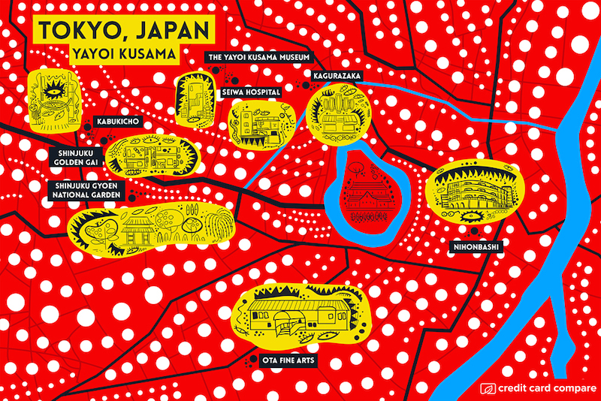

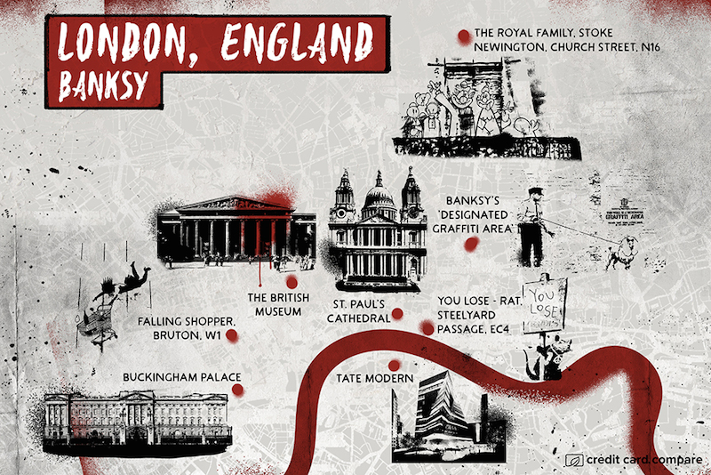

Look really closely at these artworks. Talk to a family member about what you see.

What differences /similarities do you notice?
What elements of the artist’s work do you recognise?
What do these maps tell you about the cities they represent?
Which famous artists would create a map for your hometown, and what would it look like?

Activity 2
Flags -Alexandre Da Cunha

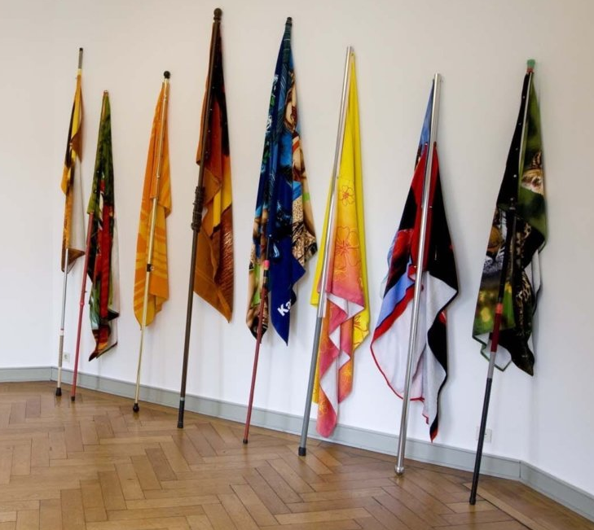
Alexandre Da Cunha has used found beach towels, curtain poles and mop handles to create flags at rest.
Could you make flags from things you find around the house or from your walks?
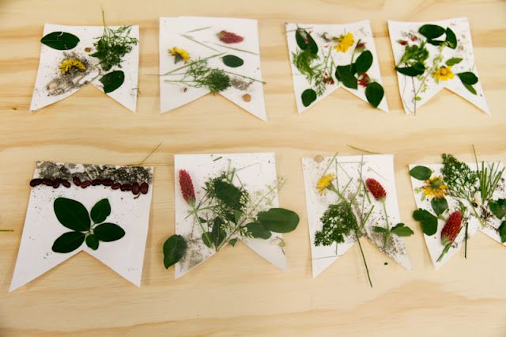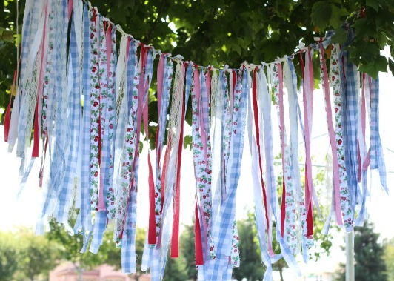

Have a go at creating your own flags using Da Cunha’s templates.
You could name your nation and give it a slogan.

PDF First site 2 Alexandre Da Cunha Flags pages 5-7

Activity 3
Create a three dimensional map
Use objects, toys, cuttings from magazines or things you collect from your walks…

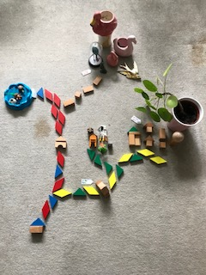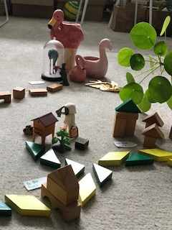
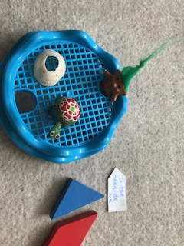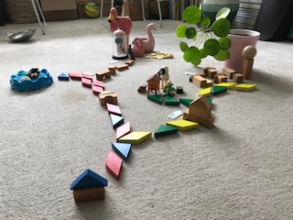

Where would your roads lead?
What signposts could you use?
What would we see along the way?

Activity 4
Mapping a place

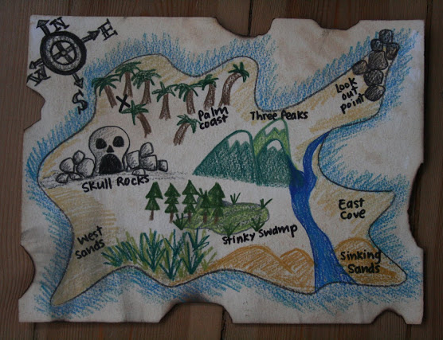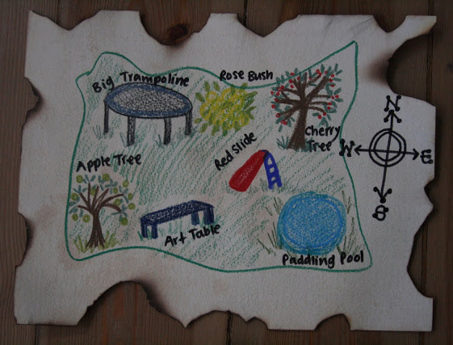

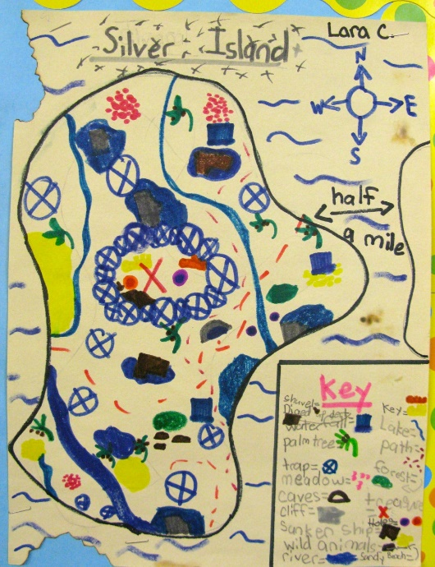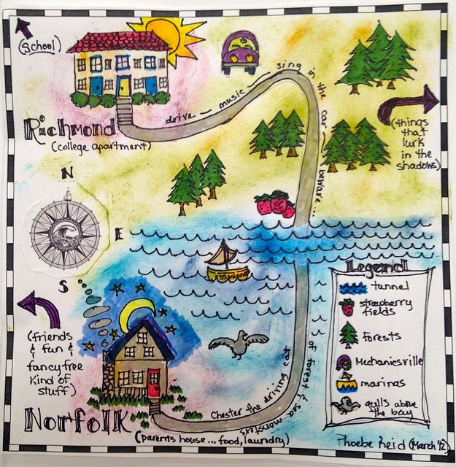

You will need:
paper, a tea bag, a mug, warm water, drawing and colouring materials
Ask an adult to put some warm water in the mug.
Add the tea bag and wait until the water is brown.
Crumple up your paper and tear the edges to give it an aged effect.
Squeeze most of the water out of the tea bag and use it to ‘paint’ over the paper, making some parts darker than others.
Once the paper is dry you can start creating your map.
Think about the place you would like to map, it could be from your imagination, your house or garden or inspired by a book or a poem. You could practise your ideas on scrap pieces of paper.
Draw, colour and label your map. You might want to add a compass or symbols and a key.

Activity 5
Mapping yourself
It’s good to think and talk about how you feel. It’s important to recognise that often we feel more than one thing at a time. Creating a map about yourself is a way of exploring your feelings, ideas and to think about the things that make you you.
You could use the examples below as inspiration or print out/ copy the Mapping Myself template.
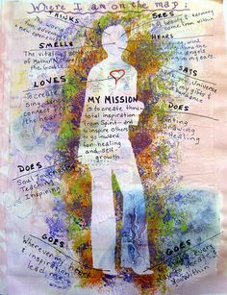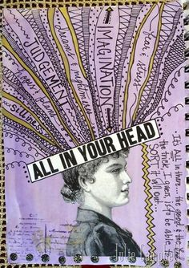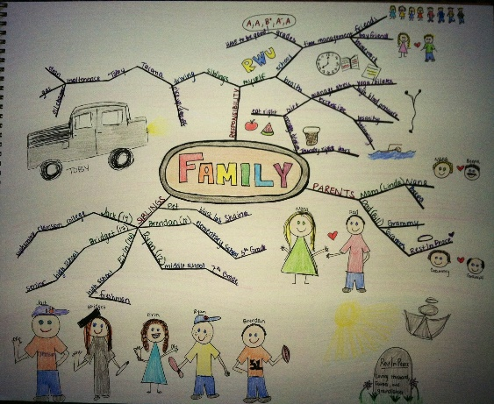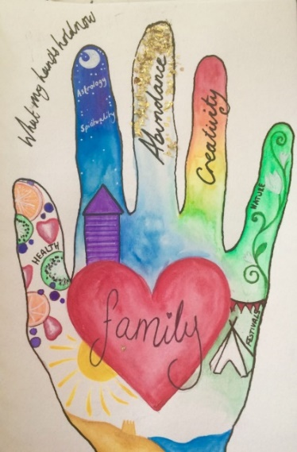
PDF Mapping Myself
TB

