Colour in Art
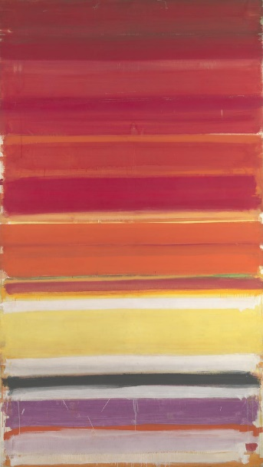
Patrick Heron
Horizontal Stripe Painting : November 1957 - January 1958
Hi Everyone,
Cy Twombly is probably my favourite artist. I love the way he uses colour, marks and words in his paintings. He often paints on a massive scale, dripping and smearing the paint over the canvas. I think this gives his paintings a feeling of being alive.
These four paintings are part of a series about the seasons. You might have noticed colours changing with the seasons.

Can you guess which season each painting represents?

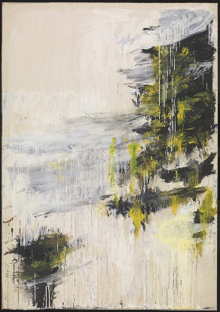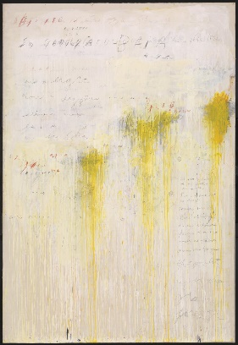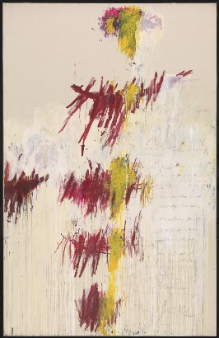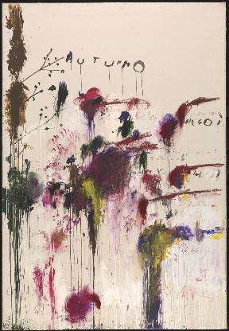

Have a go at the tasks below and send me some of your fantastic efforts.
Ms Hanif-Banks
art@sjsc.southwark.sch.uk

Activity 1
Art Appreciation
Take a look at these artworks by famous artists.

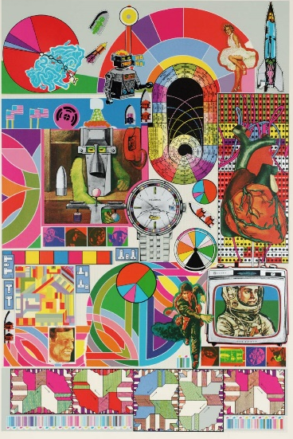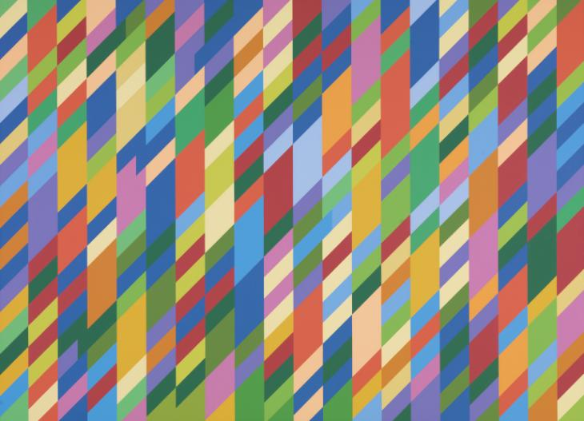
Eduardo Paolozzi –Bash 1971 Bridget Riley Nataraja 1993

Look really closely at these artworks. Talk to a family member about what you see.
What differences /similarities do you notice?
Which shades and tints of each colour can you see?
(Remember –tints are lighter; shades are darker)
Look at Eduardo Paolozzi’s Bash painting for 1 minute, how many different things/objects/shapes can you remember?
Which colour combinations do you think work well together?

Activity 2
Felt tip pen and water art
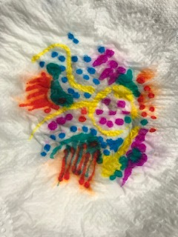
I used 2 sheets of toilet paper on top of each other and a paintbrush to drop the water.
https://www.youtube.com/watch?v=BhGvWVlmkZM

Activity 3
Still life with colour
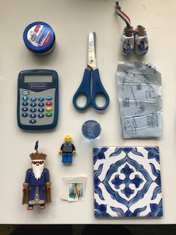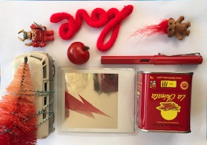
This is one of my favourite things to do! Here we are using colours, but it’s also a great way to play around with grouping objects.

pdf still life with colour

Activity 4
Create a Name Doodle
Joan Miro’s work incorporated colour in a bold and dramatic way.
Write your name, letters or a word randomly across a piece of paper, turning the paper so that some are upside down or sideways.
Next, draw wandering lines from one letter to the next until all of the letters are connected and the paper is covered with a linear pattern.
Now, use colour to fill in the shapes/spaces to create an abstract composition.
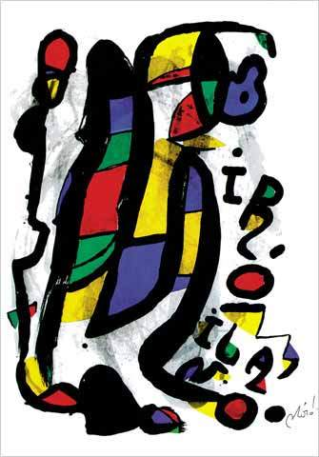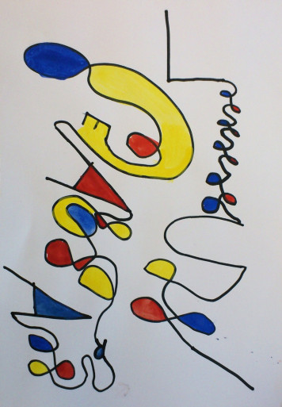

Activity 5
Using your senses
All of these artworks use colour in a singular way.
What do different colours make you think of?
How do the colours make you feel?
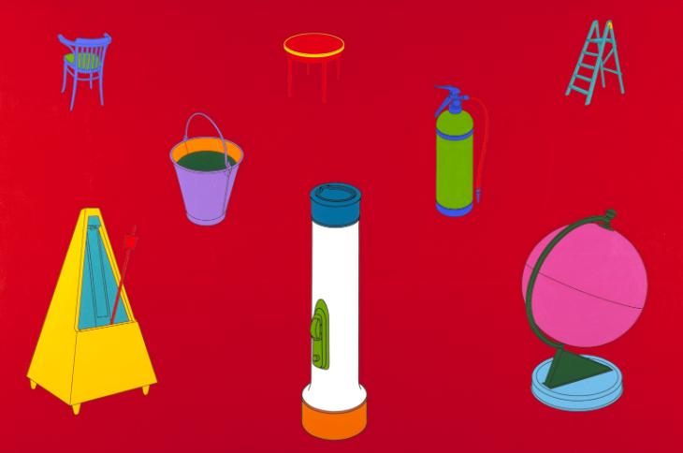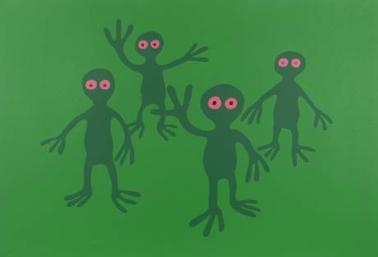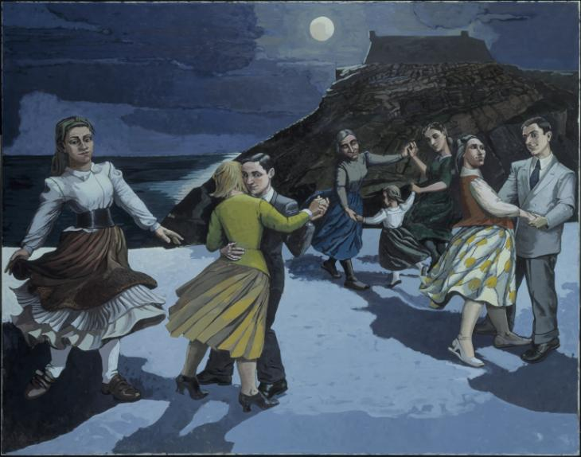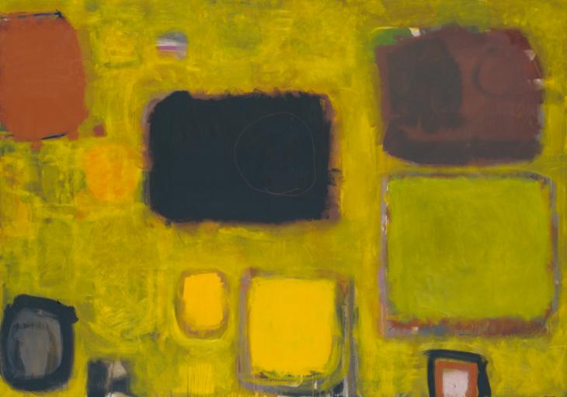
How could you describe colours through different senses?
If red were a smell what kind of smell would it be?
If you could touch yellow how would it feel?
If blue had a taste what would it be?
If green made a sound what would it be?
If purple were an object what would it be?

