Fairy tales and Mythical Creatures in Art
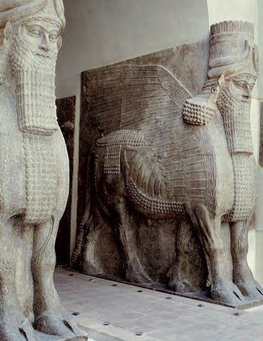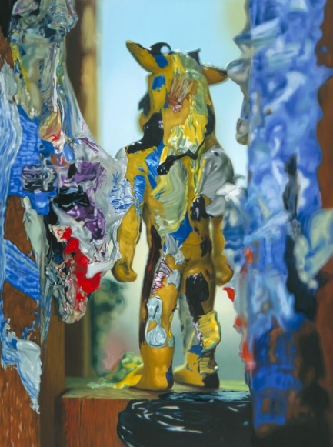
Richard Patterson –Painted Minotaur 1996
Hi Everyone,
The human-headed winged bulls and lions that stood at the gateways of Neo-Assyrian (c. 911–609 BC) palaces at Nineveh, Nimrud and Khorsabad are among the most iconic examples of ancient Mesopotamian art.
Imaginary creatures have captured the attention of artists throughout time. They help us imagine things beyond our comprehension. These creatures thrill, terrify, entertain and inspire us. They give shape to our hopes, fears and dreams.

I think the Painted Minotaur sculpture is intriguing and mysterious. It looks as though we are following the Minotaur into the labyrinth. The position of the Minotaur’s head makes me think it is looking out for danger.

Have a go at the tasks below and send me some of your fantastic efforts.
Ms Hanif-Banks
art@sjsc.southwark.sch.uk

Activity 1
Art Appreciation
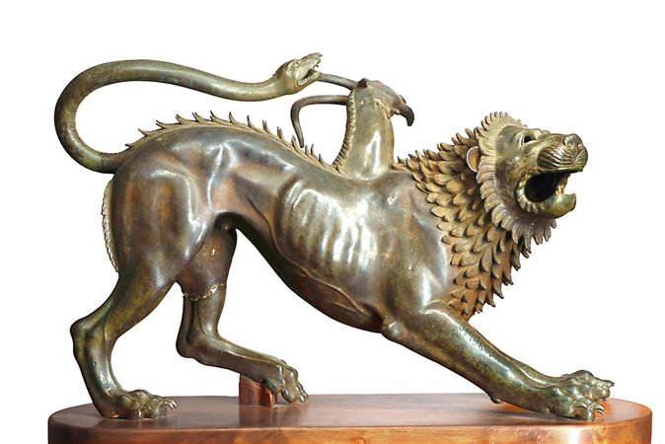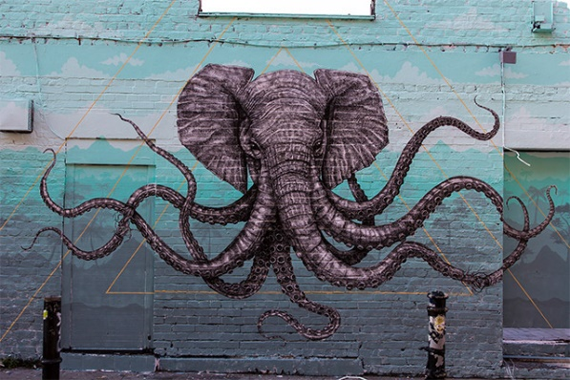
Bronze chimera, from first half of the fourth century BC Octophant – Alexis Deacon 2013
Take a look at these artworks by famous artists.
Look really closely at these artworks. Talk to a family member about what you see.
What differences /similarities do you notice?
Which animals have been combined in each artwork?
How do you think these artworks have been made?
Which 3 creatures would you join together to make a chimera?

Activity 2
Magnus Plessen – Folded Paper Characters
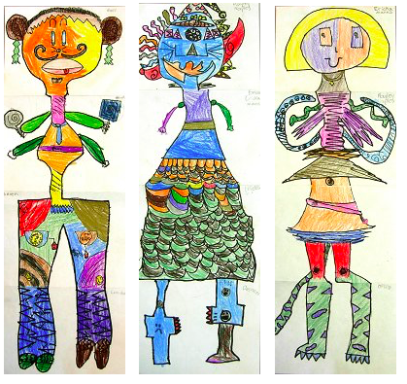
Click on the link below and go to page 18 (there are loads of other fabulous activities from amazing artists that you could do). You can play this game with 2 or more people.
file:///E:/March%202020%20online%20art%20stuff/Firstsite_Art-is-where-the-home-is_activity-pack-2.pdf

Activity 3
Create your own Chimera collage
In Greek mythology a Chimera is a hybrid creature - part lion, goat and snake.
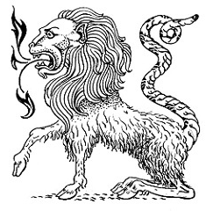
PDF
chimera collage

Listen to myths and legends from around the world. http://myths.e2bn.org/mythsandlegends/

Create your own animated stories online http://myths.e2bn.org/create/

Activity 4
Mythical creature sculptures
Do you have any broken toys, recycling or old house hold items that are no longer used? Could you fix or lay them together to make a new imaginary creature?
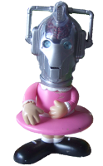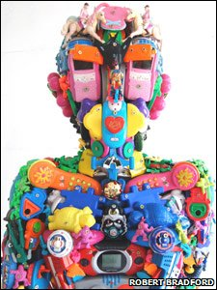

Activity 5
Use finger painting to create your favourite fairy-tale characters 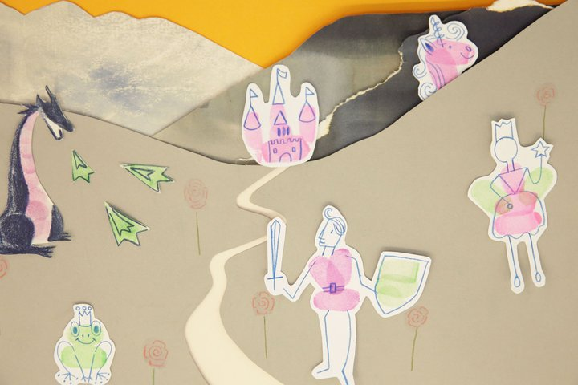 https://www.tate.org.uk/kids/make/paint-draw/draw-fairy-tale

