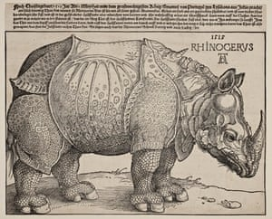
Albrecht Durer - Rhinoceros 1515
Animals in Art
Hello everyone,
Welcome to Week Three Art- Animals.
Durer was an artist and a naturalist. He had never seen a rhinoceros but made this engraving from his imagination, inspired by the description of other naturalists and explorers.

Carel Fabritius – The Goldfinch (1654)
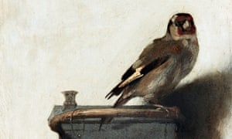
I love this painting of a goldfinch. The colours are soft and gentle and the brushstrokes show how delicate the bird is. You might have noticed or heard the birds when you have been on walks, in the garden or looking out of your windows. Art can help us explore our relationship to wildlife and can help us think about how we care for animals and the environment.
Have a go at the tasks below and upload some of your fantastic efforts to (there will be an email address, not yours but a new art one).
Mrs Hanif-Banks
Activity 1
Art Appreciation
Take a look at these artworks by famous artists.
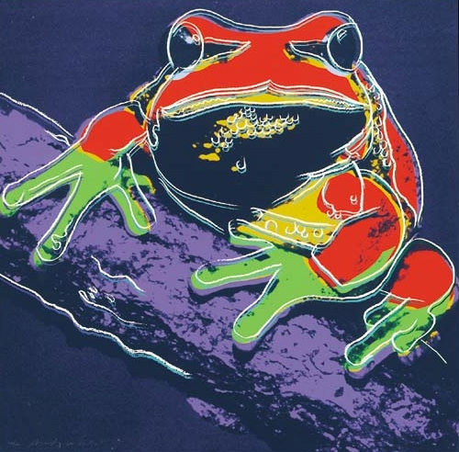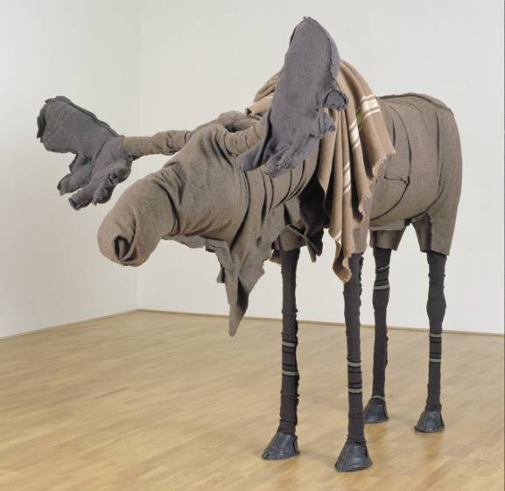
Pine Barrens Tree Frog – Andy Warhol Moose – Laura Ford

Look really closely at these artworks. Talk to a family member about what you see.
What differences /similarities do you notice?
How do you think the artists have shown the animals’ characteristics?
How have these artworks been made?
Do you have a pet or a favourite toy you could draw or paint?

Activity 2
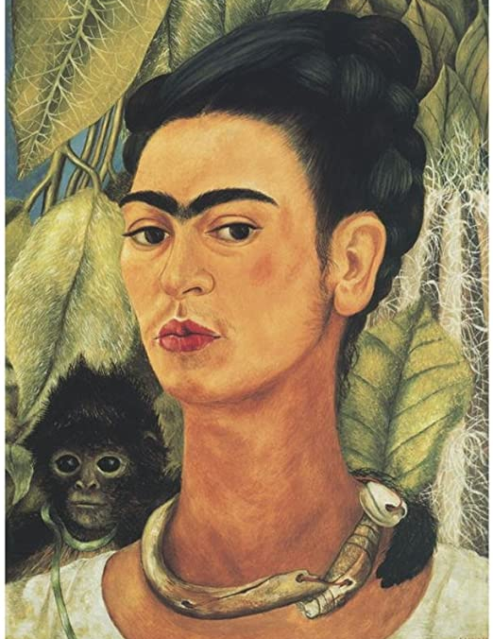
Frida Kahlo often painted self-portraits showing her unique, flamboyant style alongside different animals and birds. Do you have a favourite item of clothing or jewellery? Why are these things special to you? Do you have a pet or a toy that you treasure? Think about how you could create a self-portrait inspired by Kahlo’s love of nature. You could take a photograph, create a sculpture or look in a mirror and draw what you see.
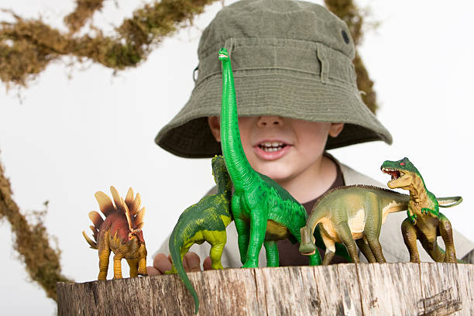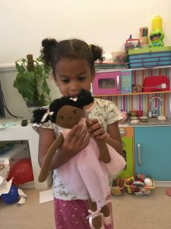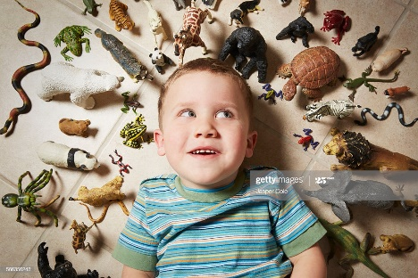
Activity 3
Step-by-step drawing tutorial - How to draw a ladybird or butterfly
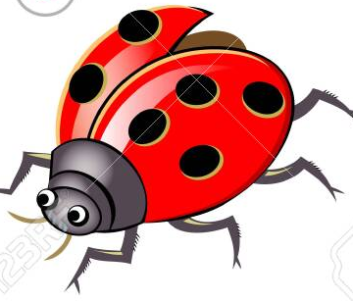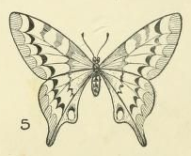
https://pdfhost.io/v/s62s~bJ5A_Step_by_step_how_to_draw_a_ladybird_or_a_butterflypdf.pdf

Activity 4
Bringing the zoo to you!

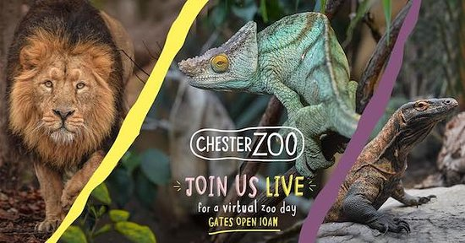

Visit the Chester Zoo website to take a virtual tour and see what the animals are getting up to.
https://www.chesterzoo.org/virtual-zoo/
Use your own toys or animal ornaments to create shadow drawings.
https://www.chesterzoo.org/schools/resources/how-to-create-animal-shadow-art/

Activity 5
Which animal are you?
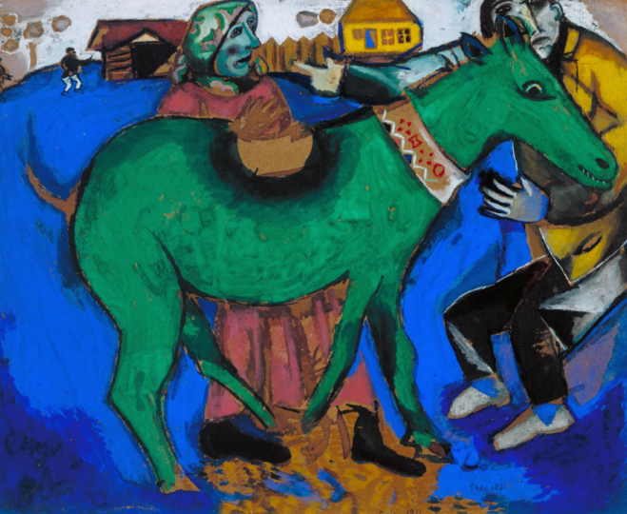
Animals have been a source of inspiration for many artists. From art about rural life and growth, to myths and legends, animals are used in art in many different ways.
The Tate Modern is a great place to see animals in art.
Try the quiz below to see which art animal you are.

https://www.tate.org.uk/kids/games-quizzes/quiz-which-art-animal-are-you

