BLC Writing moderations 2019
Year 3 examples
Exceeding – this example achieved all the success criteria, met the National Curriculum criteria and included editing.
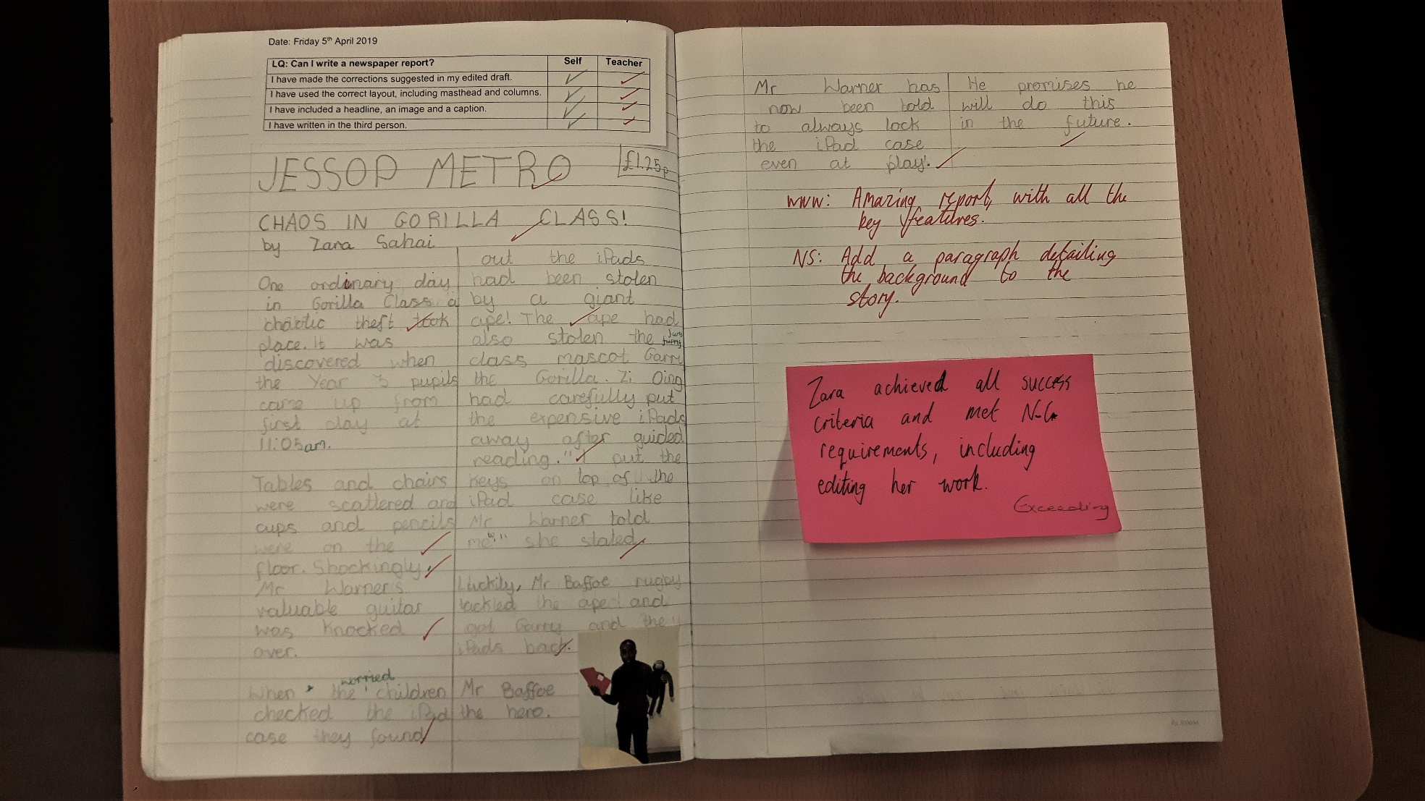
Exceeding – using a variety of sentence lengths, editing the work effectively and thinking carefully about vocabulary choices. 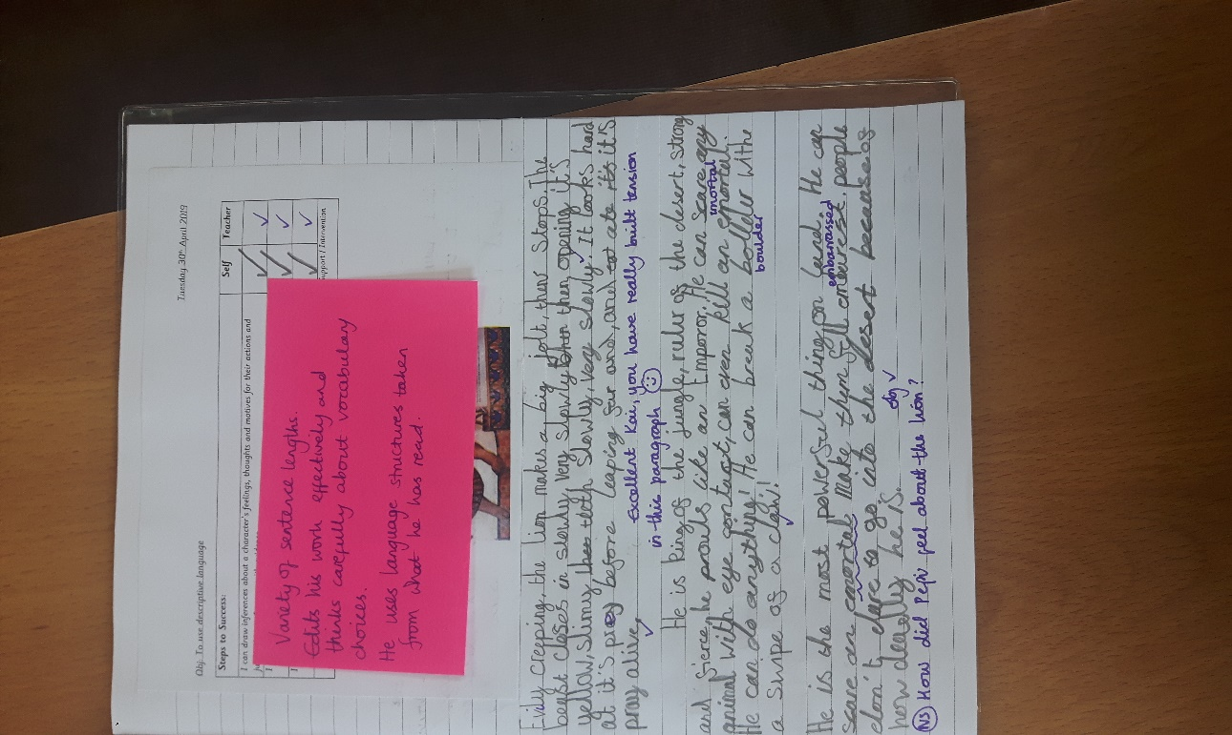
Exceeding: using a variety of sentence lengths, editing the work effectively and thinking carefully about vocabulary choices taken from things the pupil has read.

At age related expection. Able to learn spellings – often scores 10/10 in tests but doesn’t always apply this in independent writing.
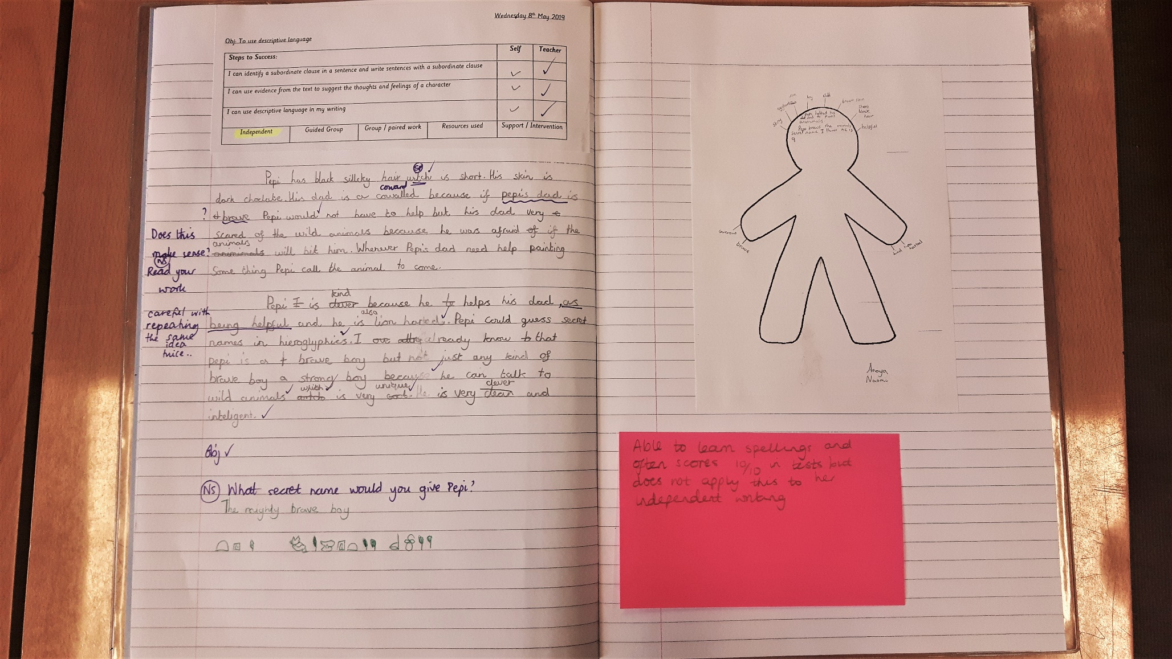

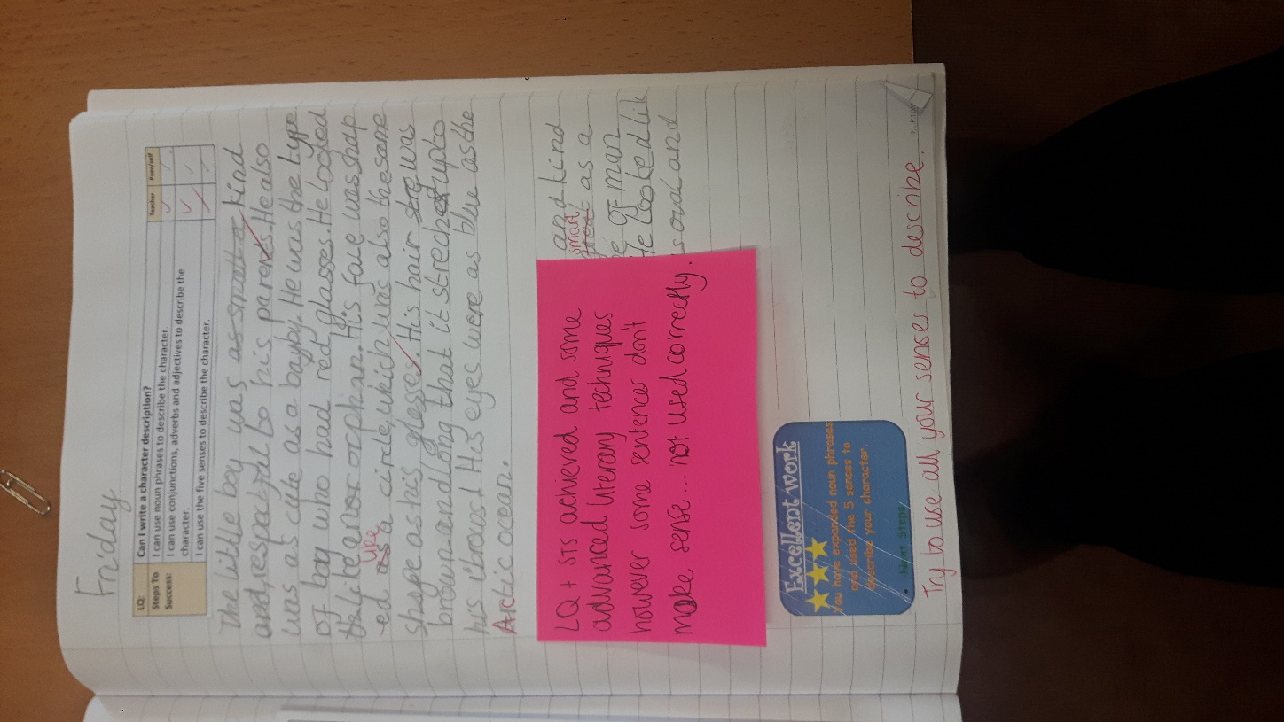
At Age related expectation.
Learning objectives achieved and some advanced literary techniques however some sentences don’t make sense as not used correctly.
Working towards: still working towards a basic level of independent work. All the work is heavily scaffolded or with adult support
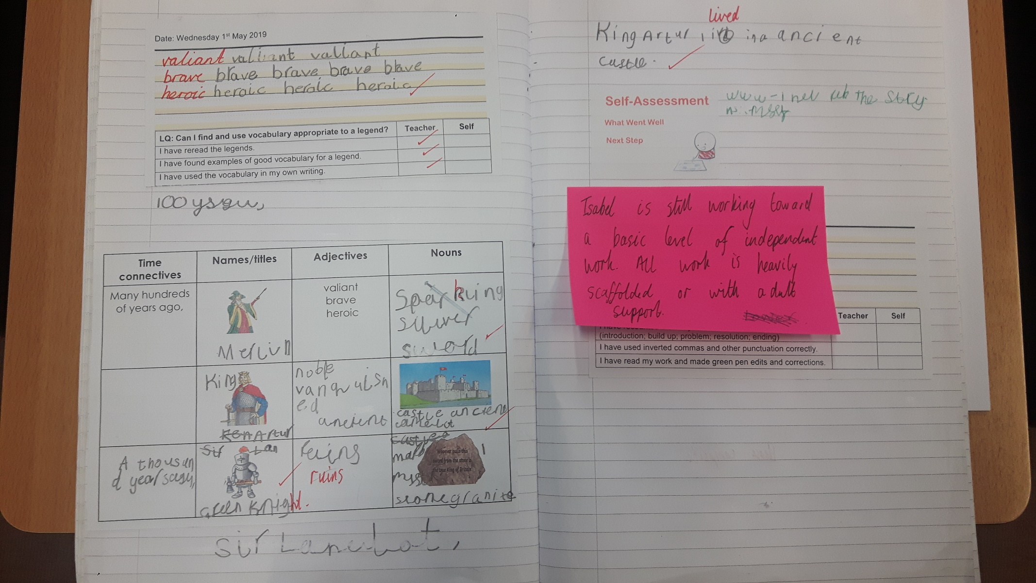

Working towards: able to use alliteration however sentences are not sometimes grammatically correct eg a/an etc
