Year 1 Moderations (March 2018)
Examples of Working towards/beginning/below
Eg 1
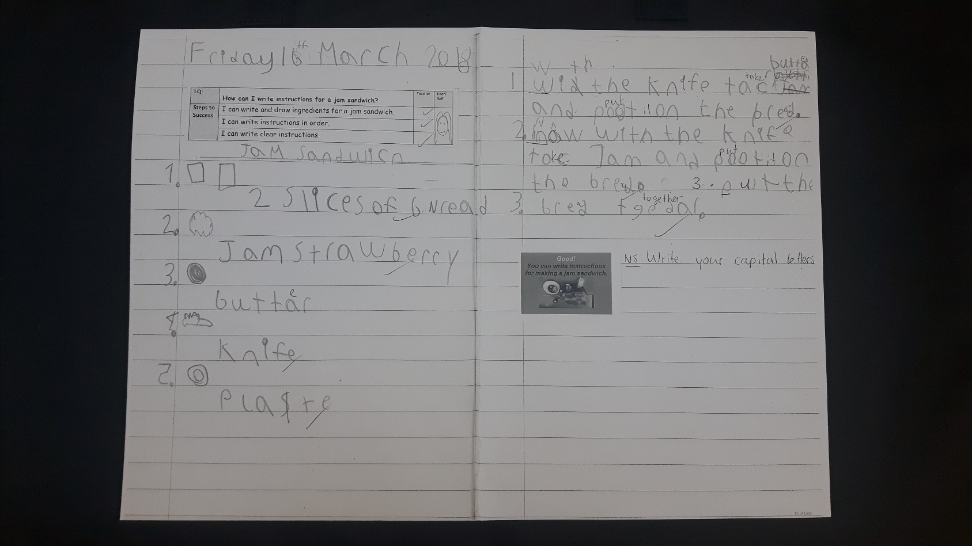
Evidence of level: uses capital letters and full stops most of the time. Uses her phonics sound mat to write.
Next steps: using finger spaces and being more consistent with using full stops and capital letters

Eg 2
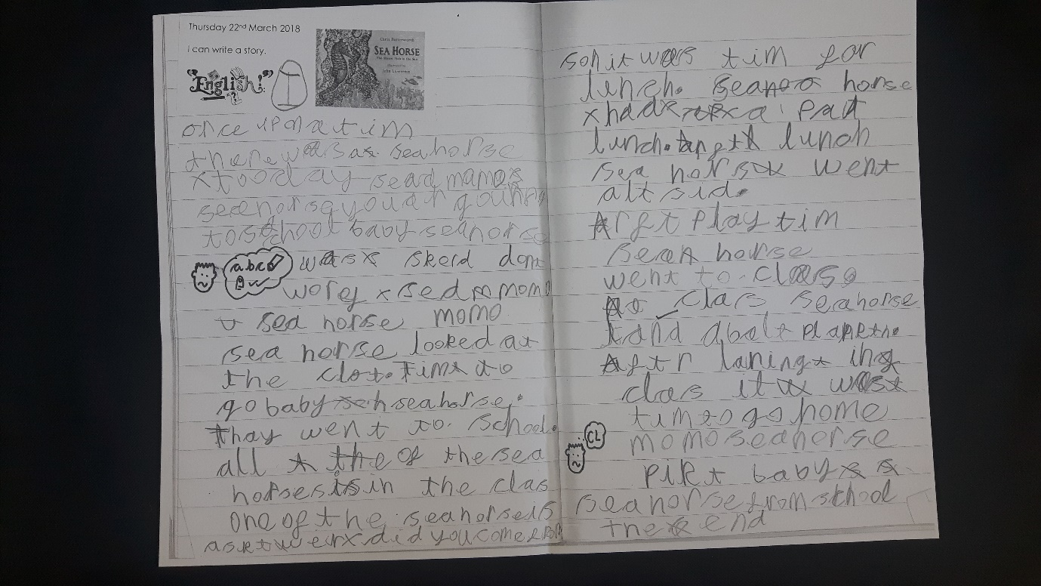
Evidence of level: starting to use capital letters and tenses.
Next steps: using simple adjectives, more consistent capital letters, suffixes.

Eg 3
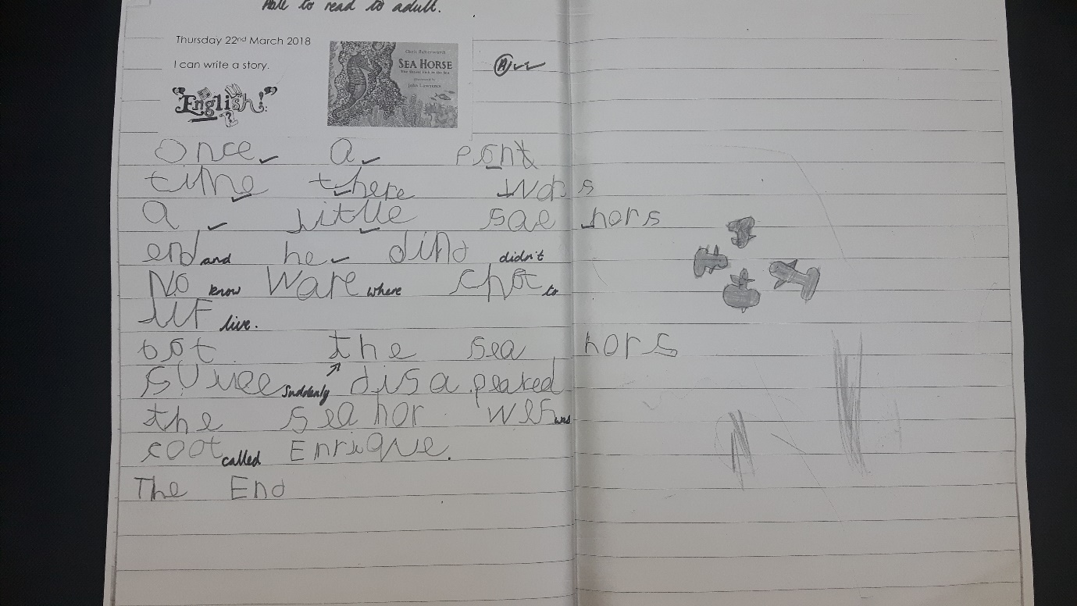
Evidence of level: can read his work, has started to use capital letters, says aloud what he writes, letters beginning to be formed.
Next steps: spellings and handwriting
Examples of At Age Related Expectation

Eg 1
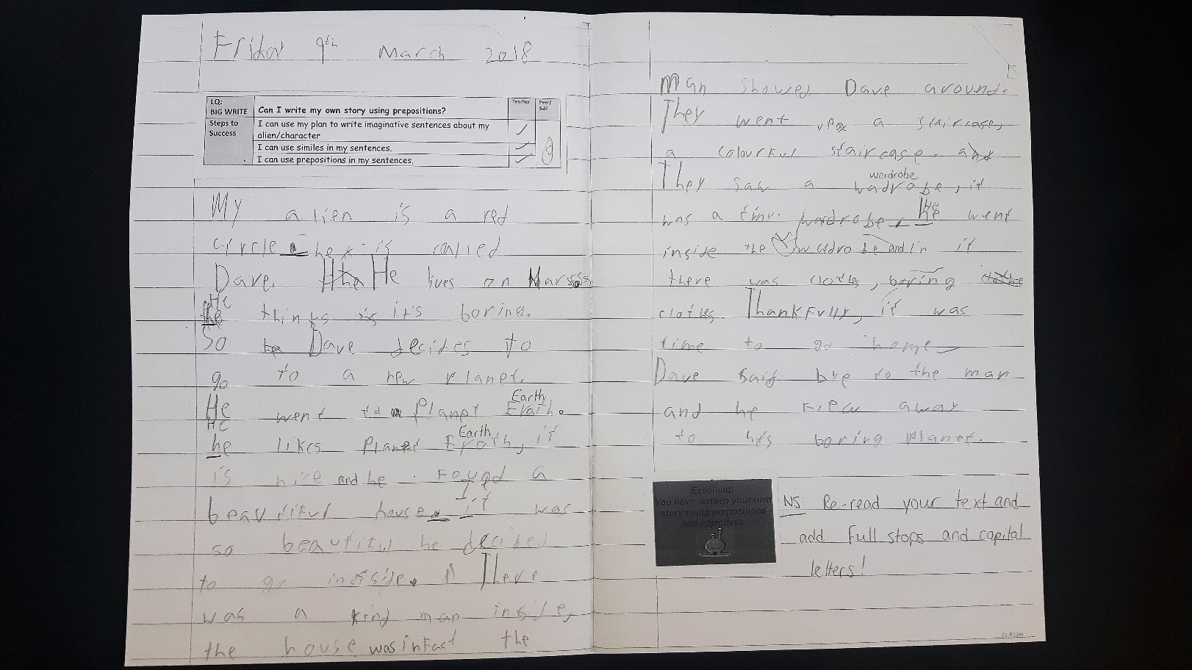

Evidence of level: consistent use of capital letters and full stops, consistent use of adjectives. Good spelling
Next steps: to take time to write more neatly

Eg 2
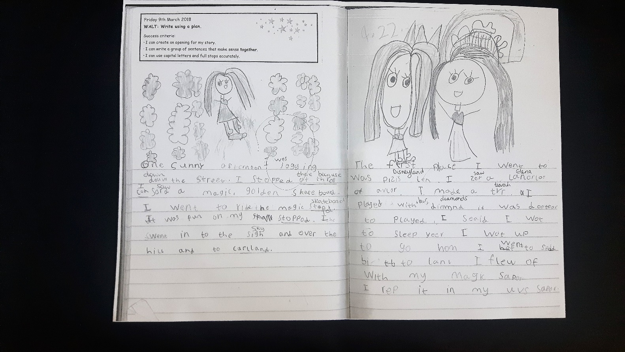

Evidence of level: using finger spaces using ‘ed’ word endings. Good use of capital letters and full stops, good sentence structure.
Next steps: more adjectives and a range of punctuation and varied sentences.

Examples of exceeding/above/secure
Eg 1
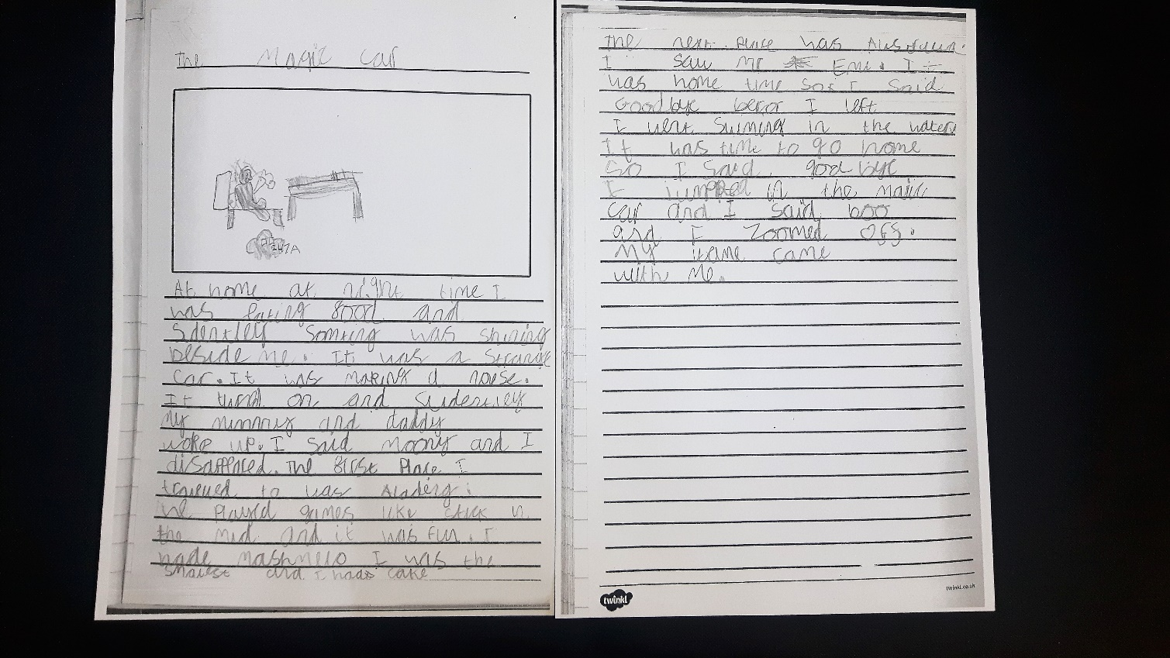
Evidence of level: joined handwriting, correct letter formation, using conjunctives.
Next steps: using a range of punctuation, writing a range of text types
Eg 2
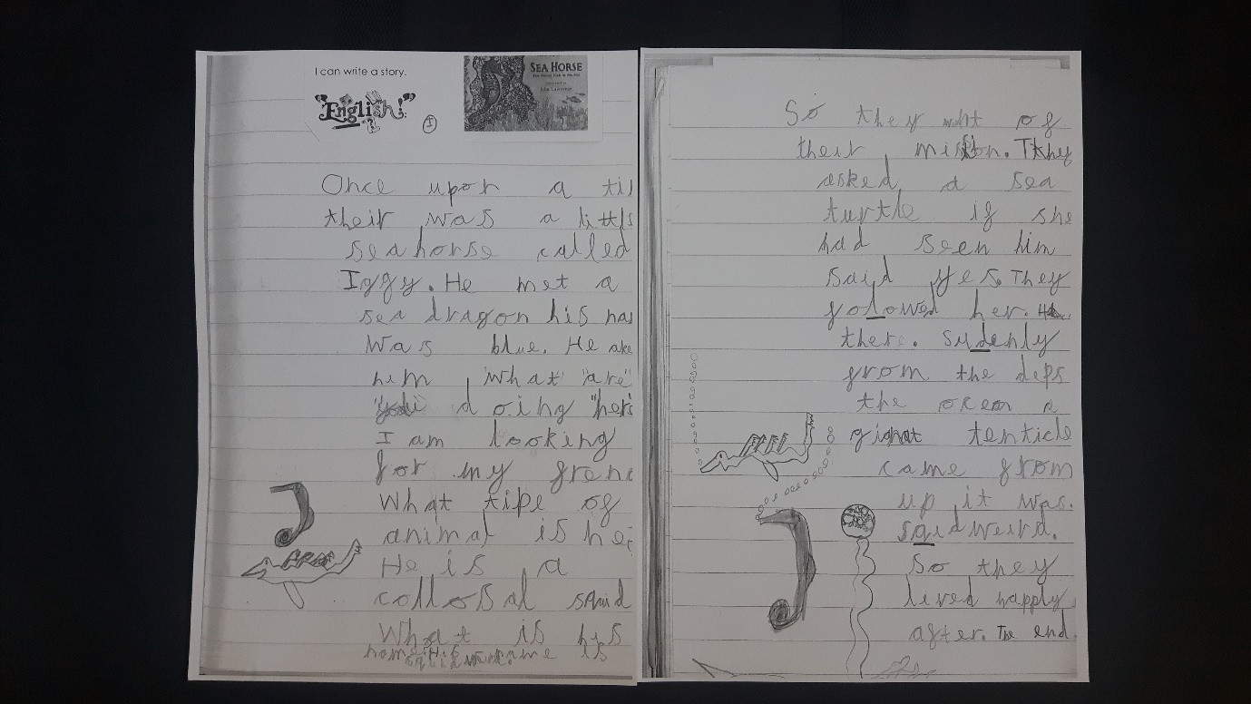
Evidence of level: capital letters and full stops, good high frequency word spelling and vocab.
Next steps: hand writing (left handed) and joining double letters.

