BLC Year 4 Writing Moderations – February 2018
Examples of exceeding/secure
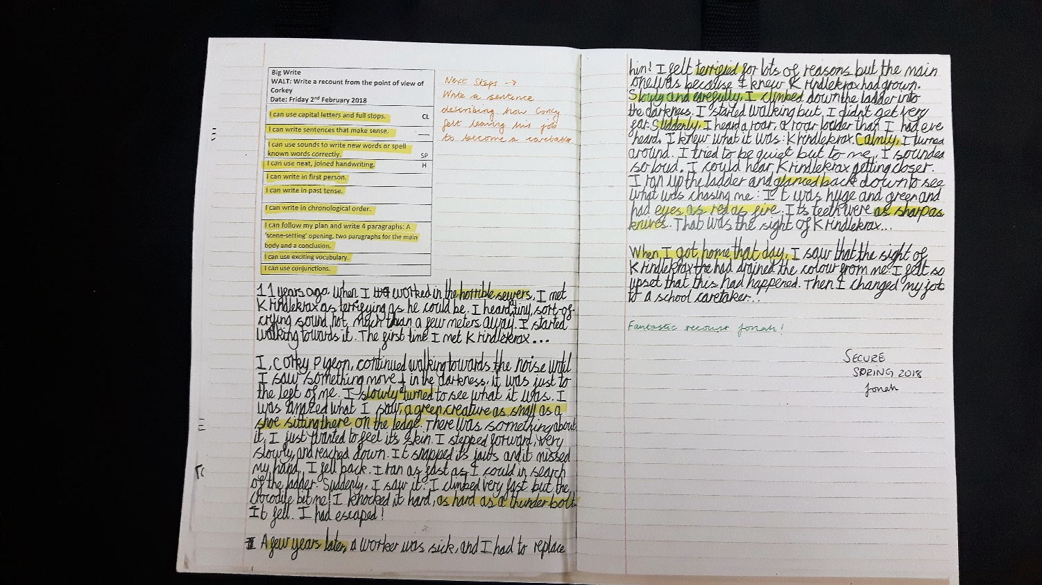
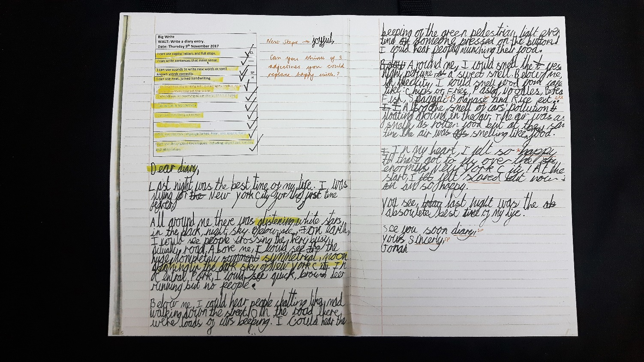
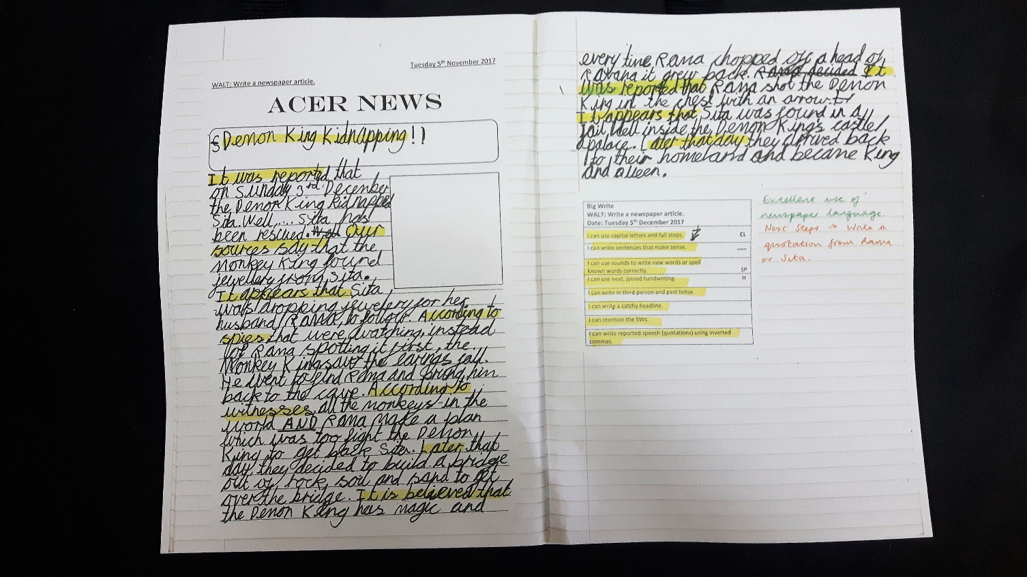
Evidence of level: using a range of exciting vocabulary and punctuation; accurate and frequent use of fronted adverbials.
Next steps: to evaluate and edit work
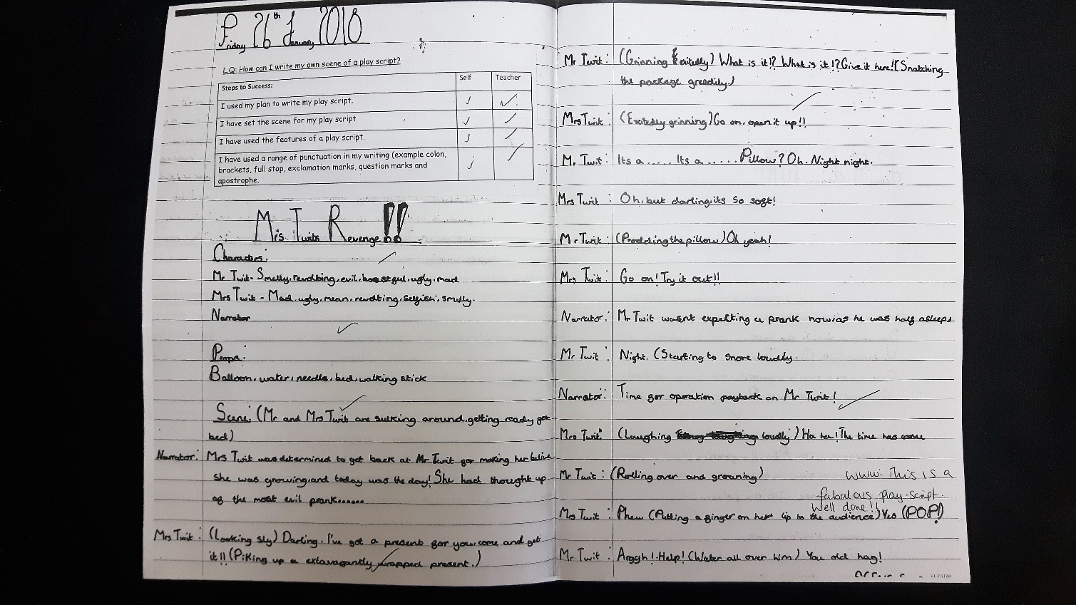
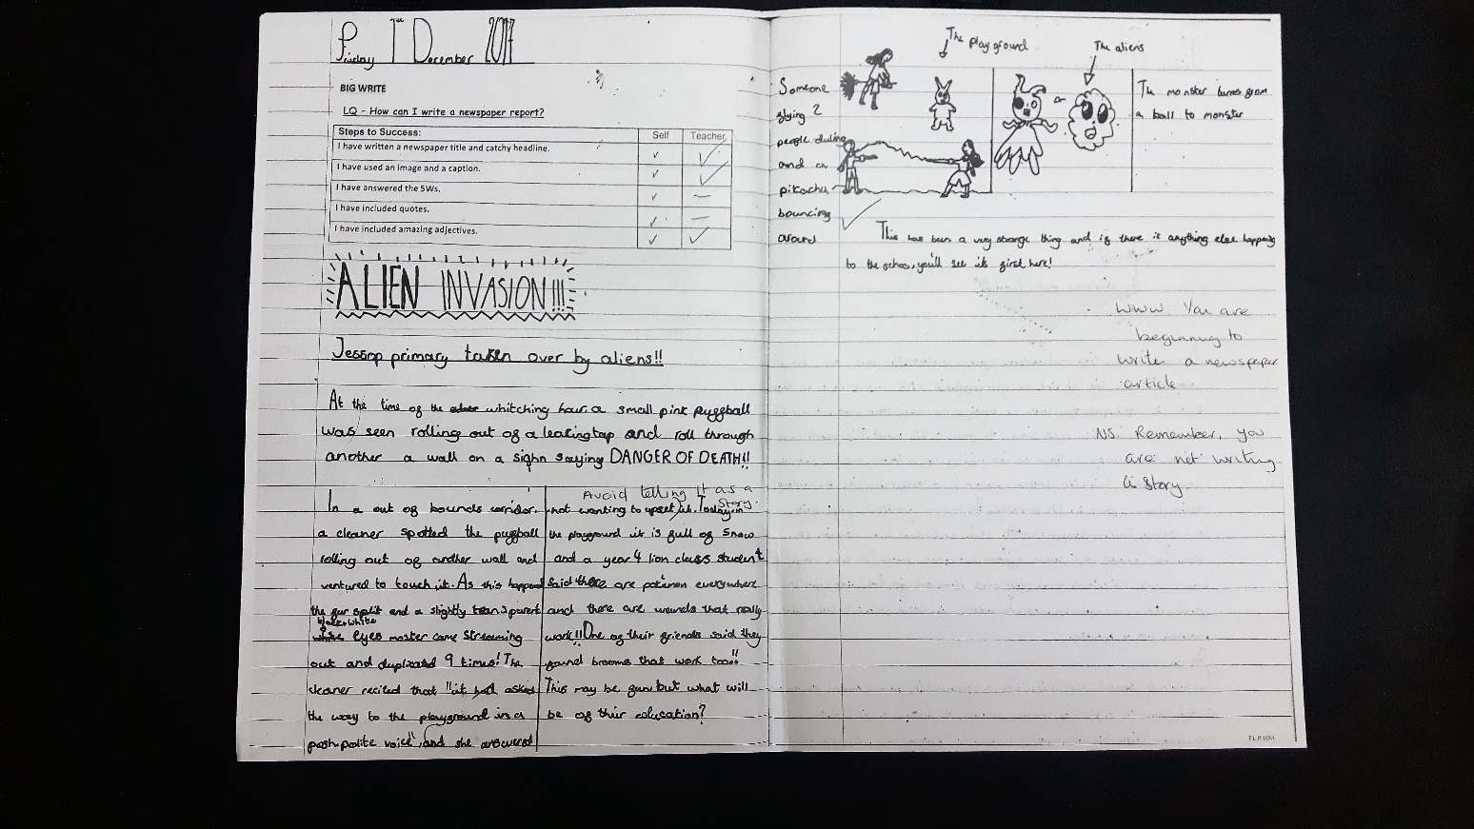
Evidence of level: using a range of vocabulary and punctuation; using emotive language.
Next steps: to evaluate and edit work
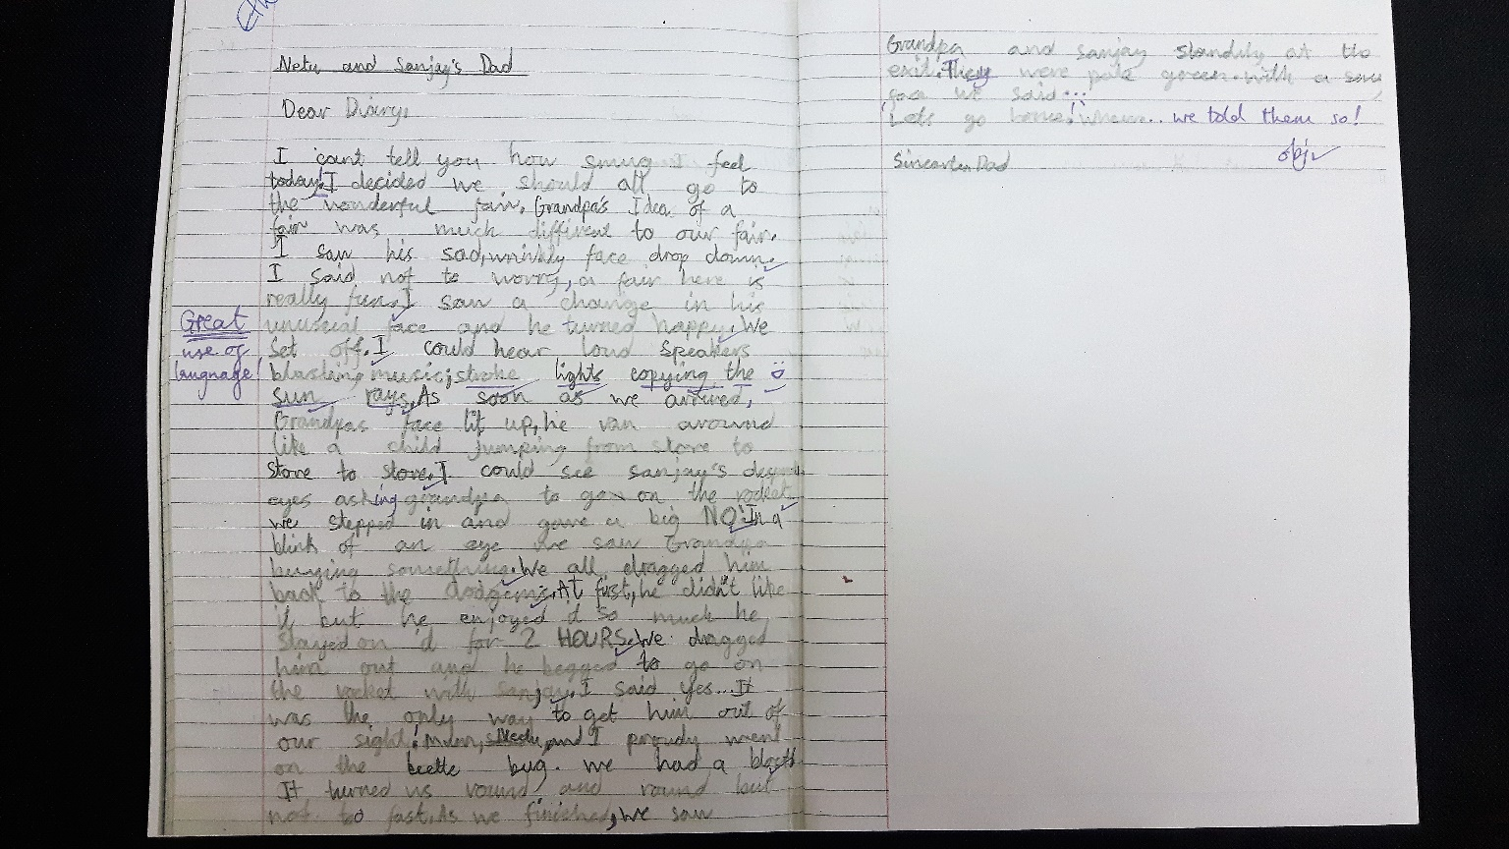
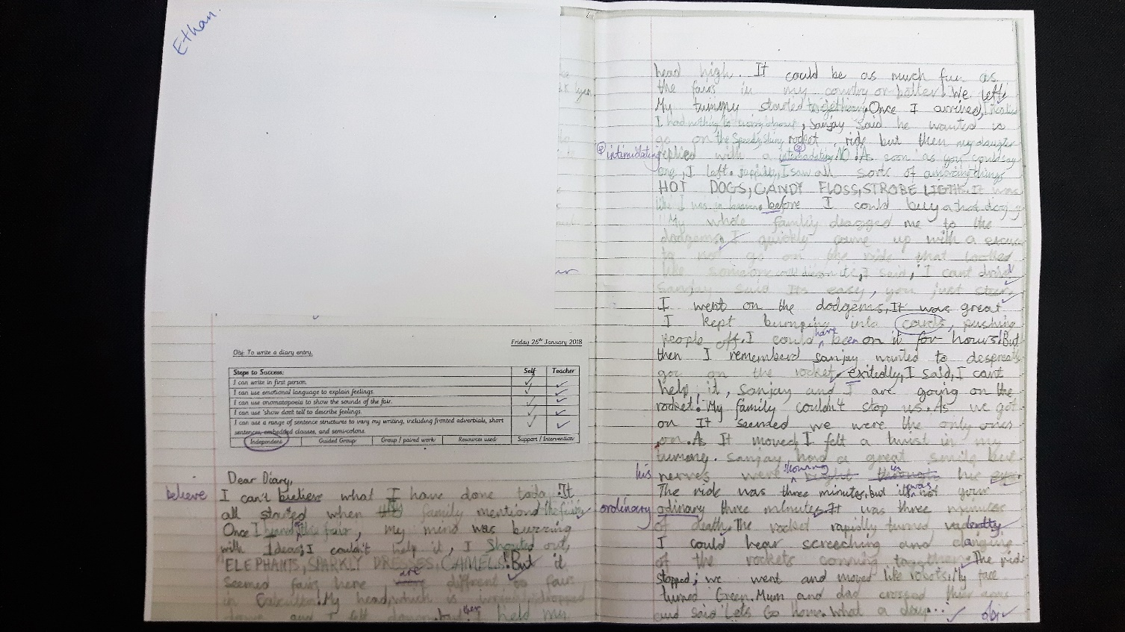
Evidence of level: varying sentences, using a range of structures, vocabulary and punctuation.
Next steps: to broaden vocabulary further; to use speech and sub-clauses in different ways
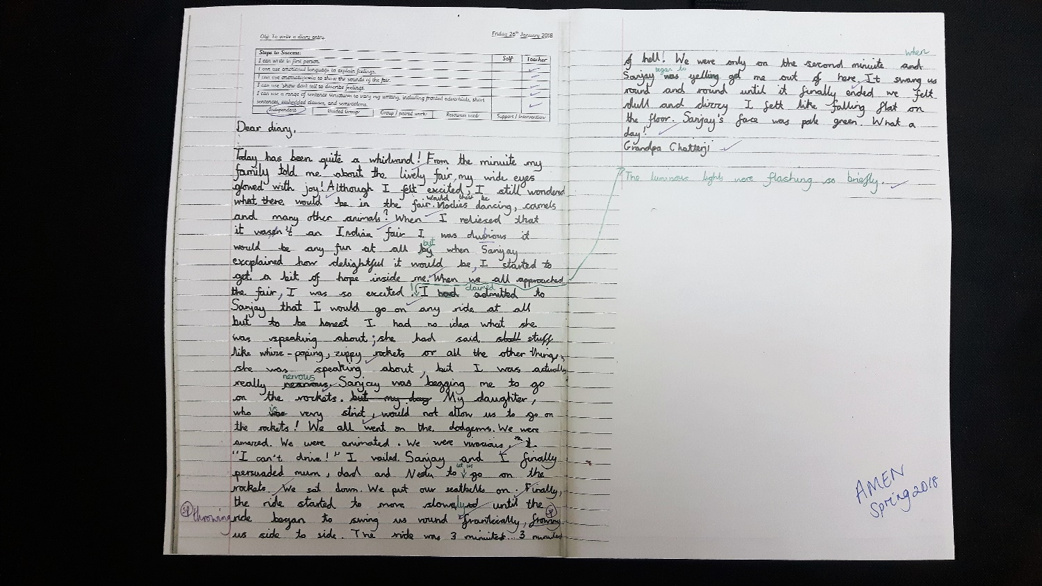
Evidence of level: technical writing ability, good handwriting and using varied punctuation.
Next steps: pushing vocabulary, wider reading to develop creativity.

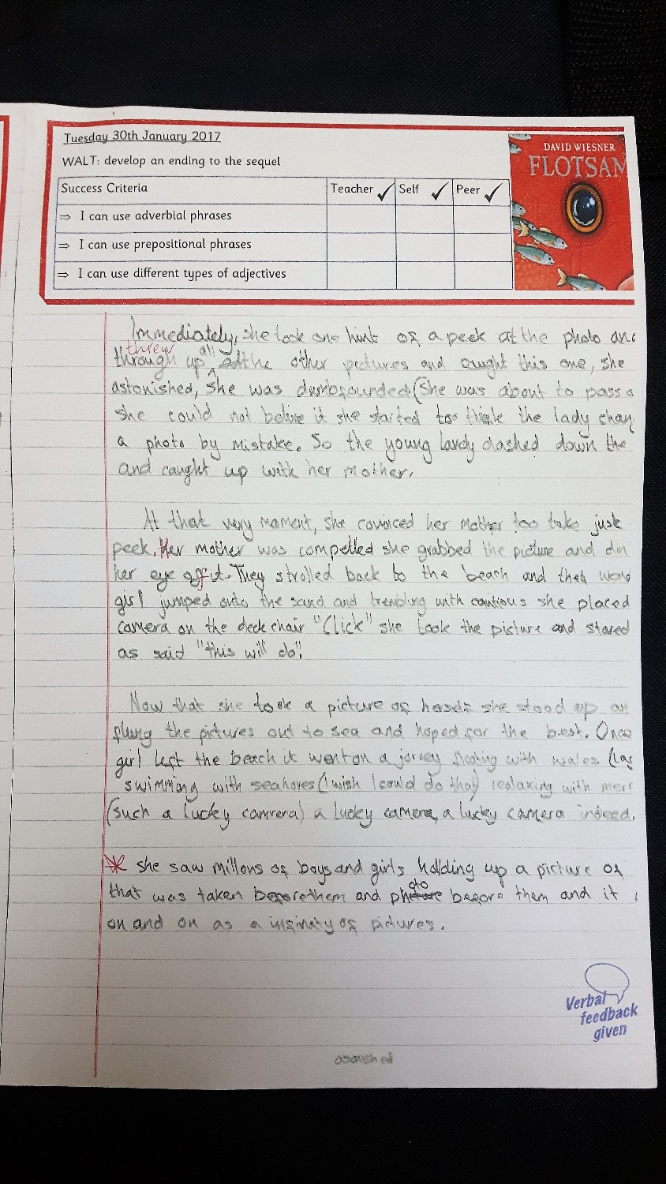
Evidence of level: using a range of vocabulary and good use of punctuation and paragraphs.
Next steps: focussing on spelling and an even wider range of punctuation.

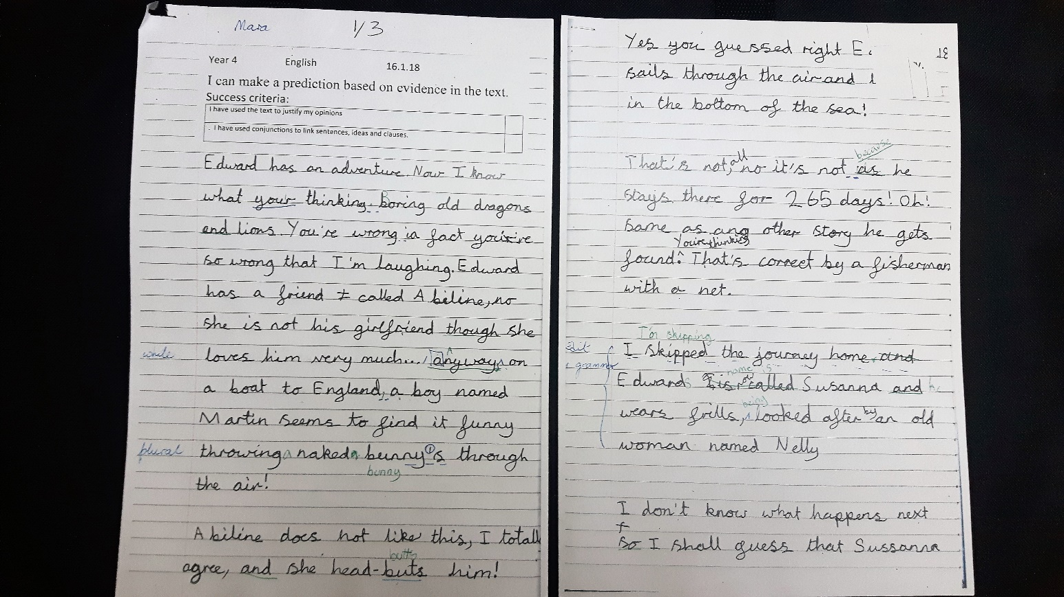
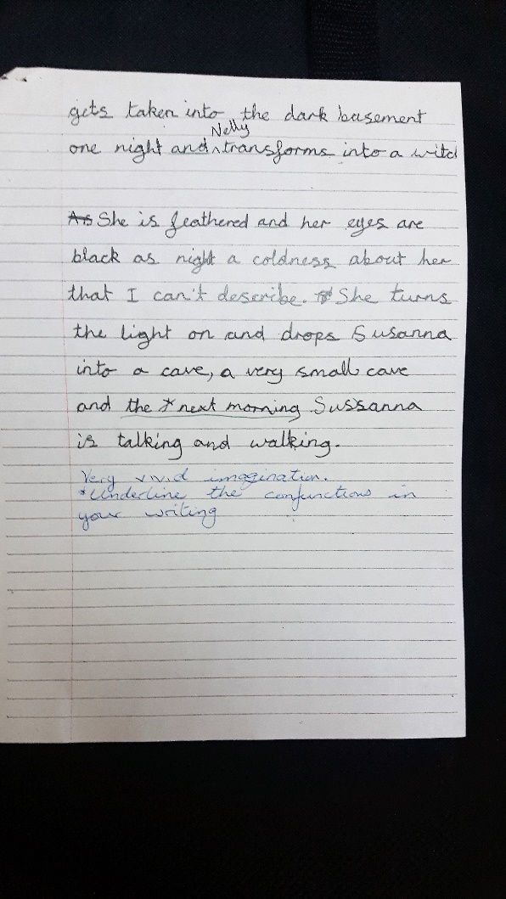
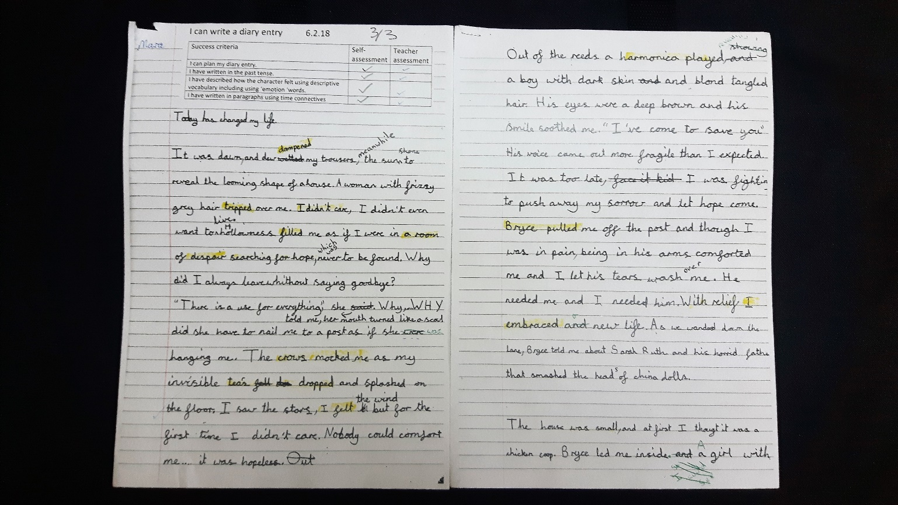
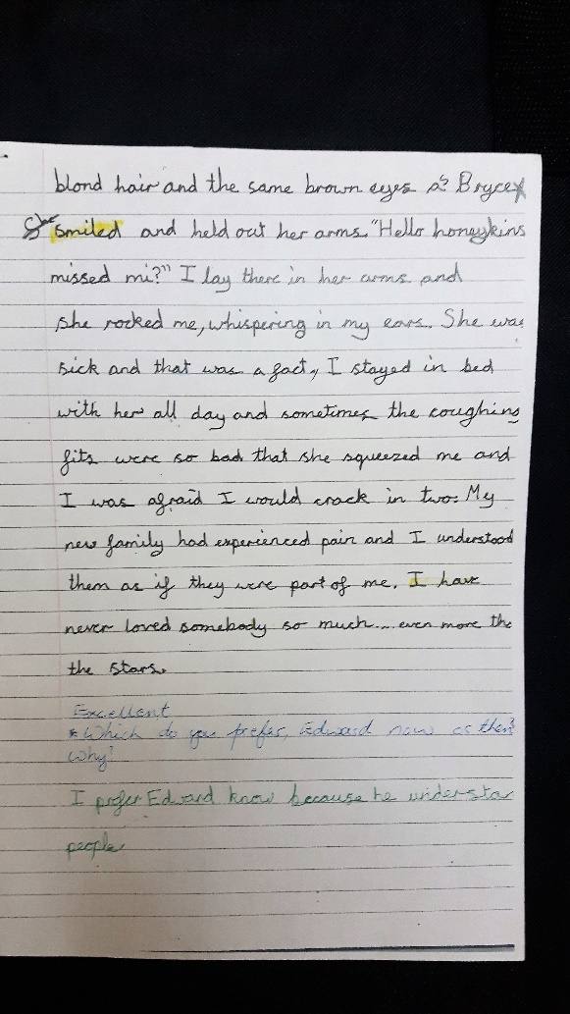

Evidence of level: uses fronted adverbials and a range of sentence starters
Next steps: consistent use of punctuation and writing for different audiences

