BLC Writing Moderations
Year 3 – examples of writing ‘at’ age related expectation.
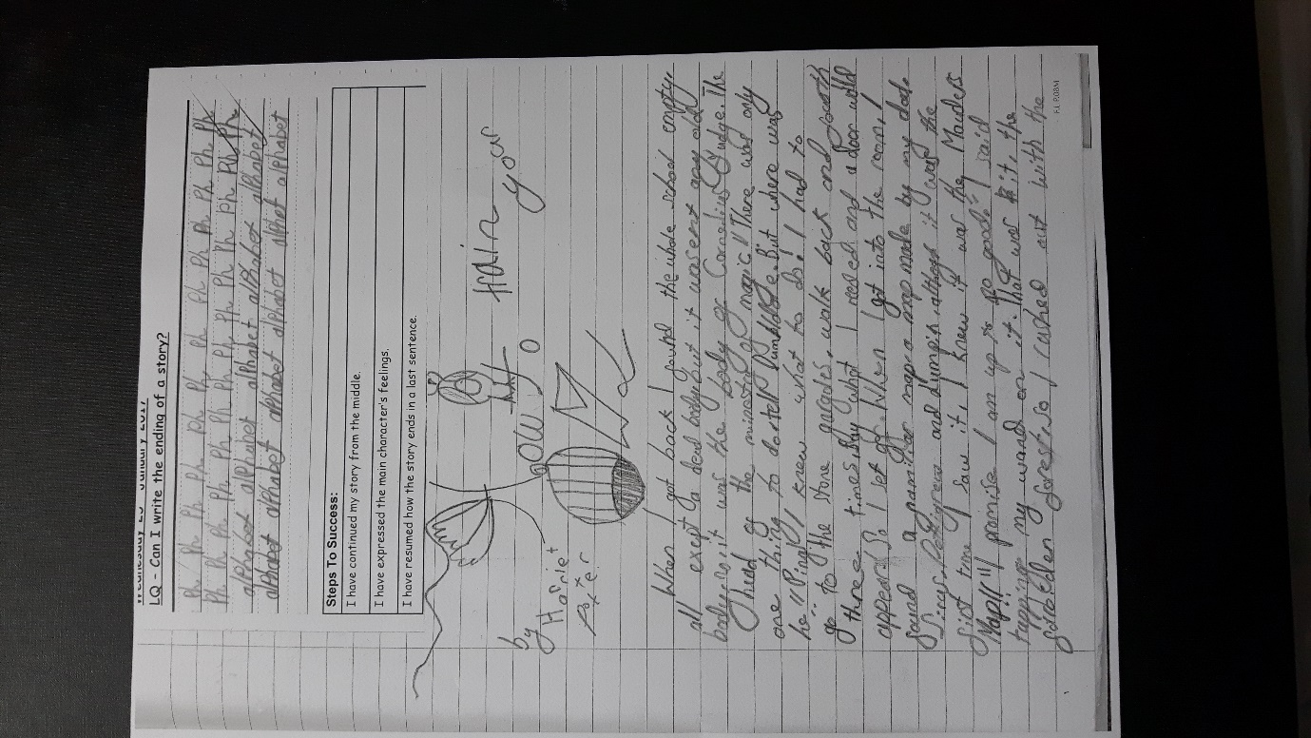

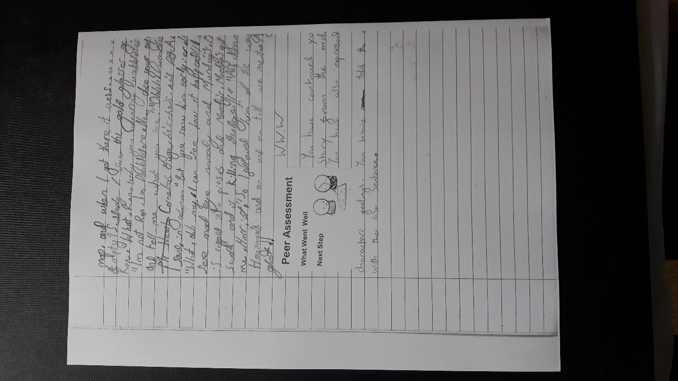

Evidence of level: Use of exclamation marks, using commas to indicate subordinate clauses, variety of sentence structure for effect
Next steps: joining handwriting, consciously selecting/developing use of adjective

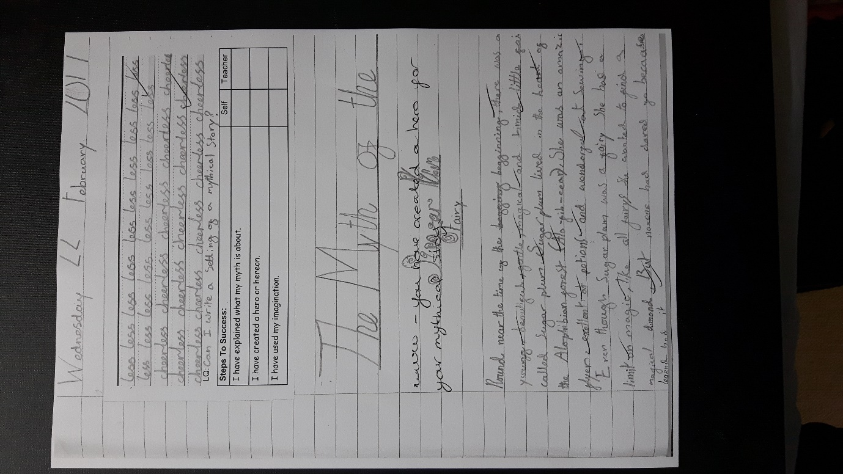

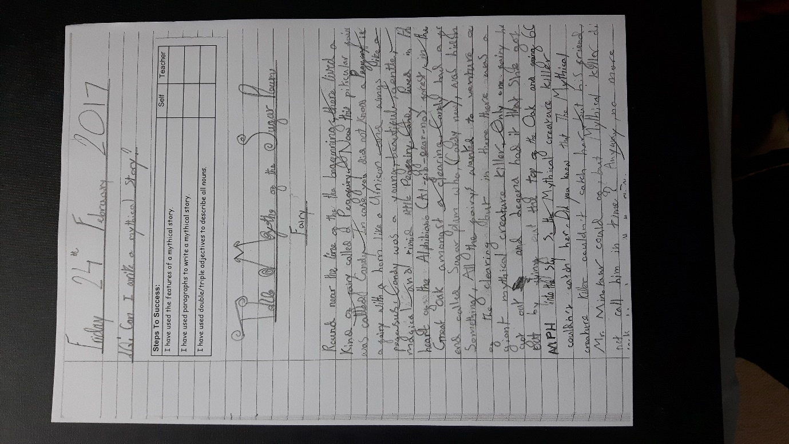

Evidence of level: writing for a variety of purposes, using commas in lists and brackets for more information
Next steps: developing punctuation – apostrophes for contractions; developing appropriate language for descriptons (similes)

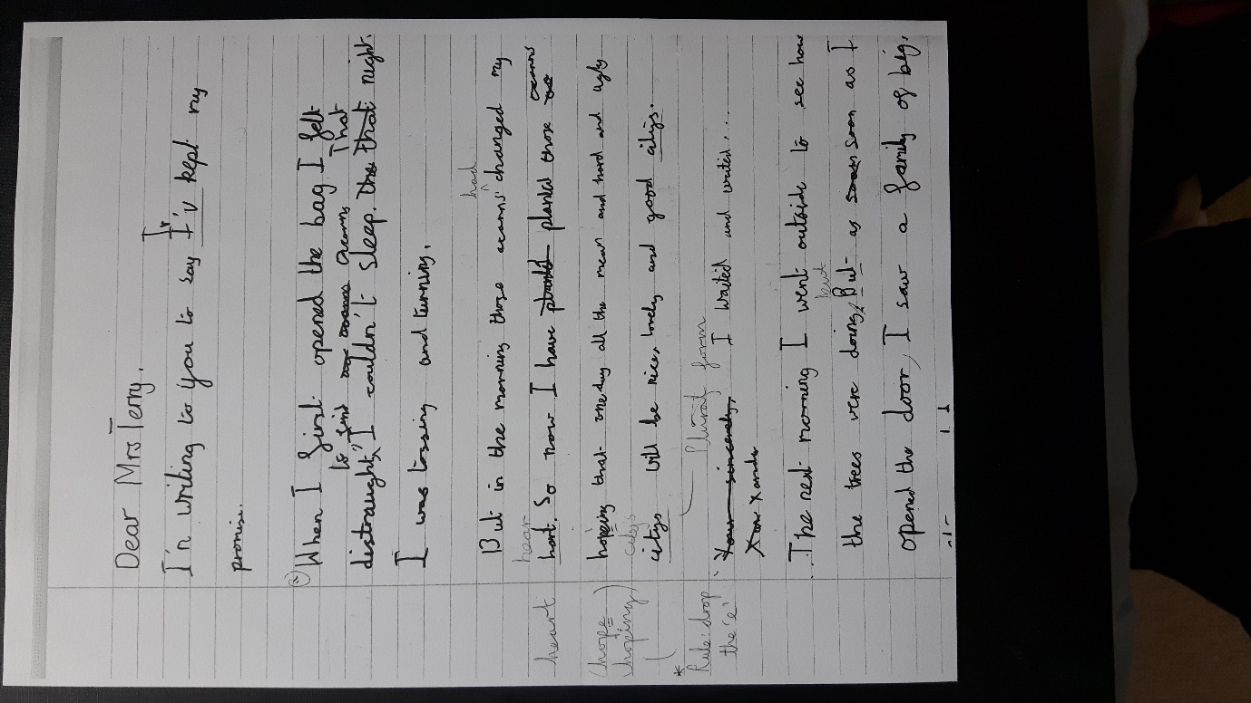
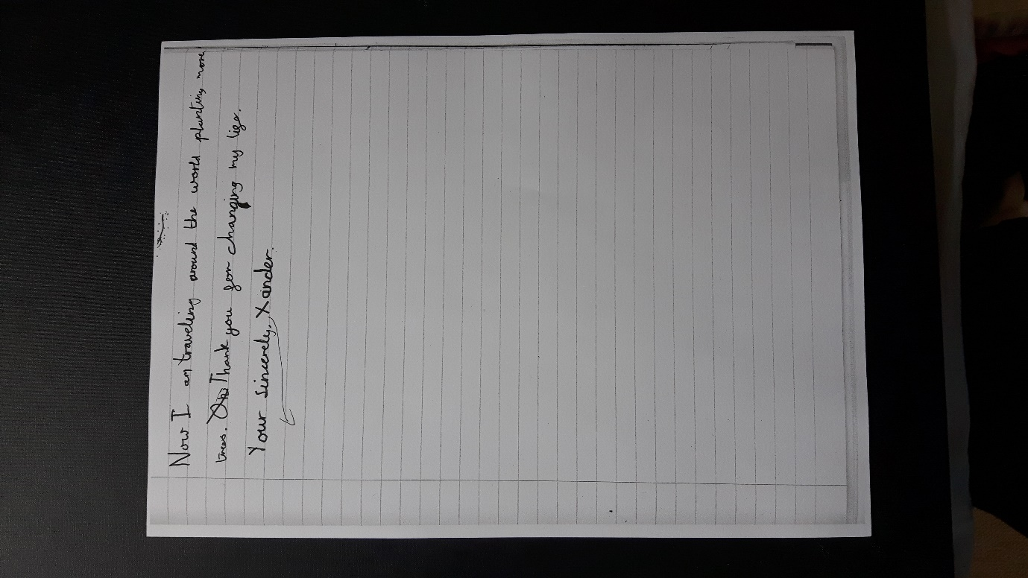

Evidence of level: Using Capital letters, apostrophes, paragraphs, speech marks for dialogue. Describing the setting
Next steps: using adverbials and fronted adverbials.

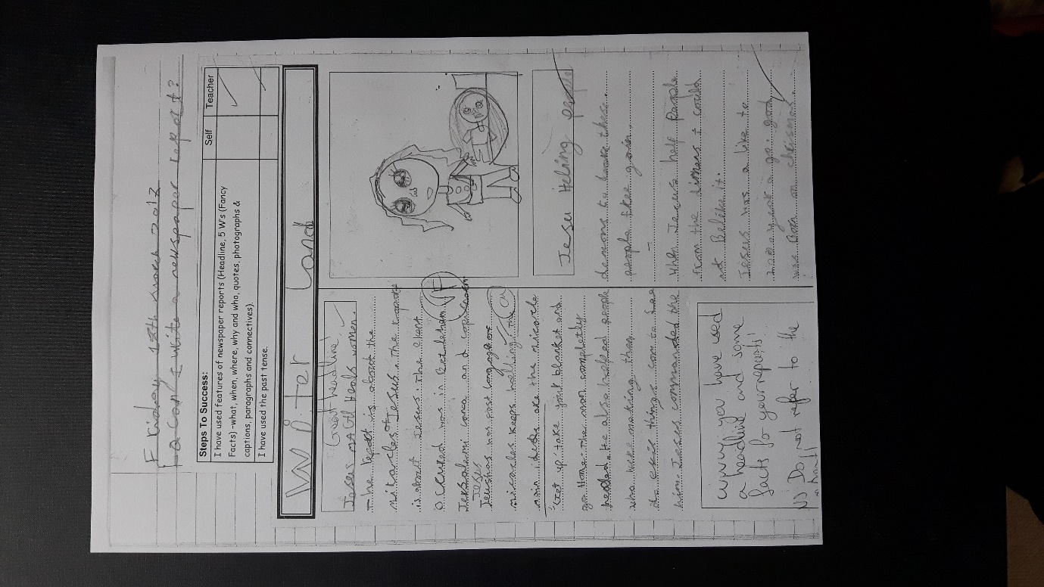

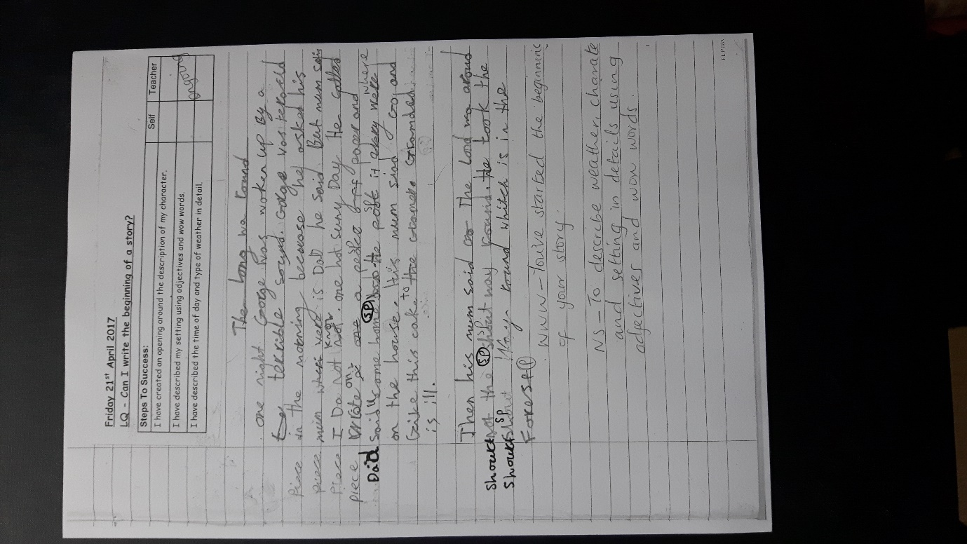

Evidence of level: use of capital letters, sentence starters, plural nouns, paragraphs, adjectives
Next steps: apostrophes (possessive), fronted adverbials, adverbs.

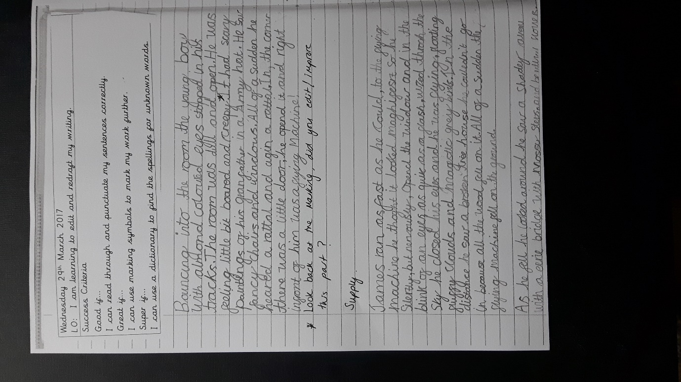

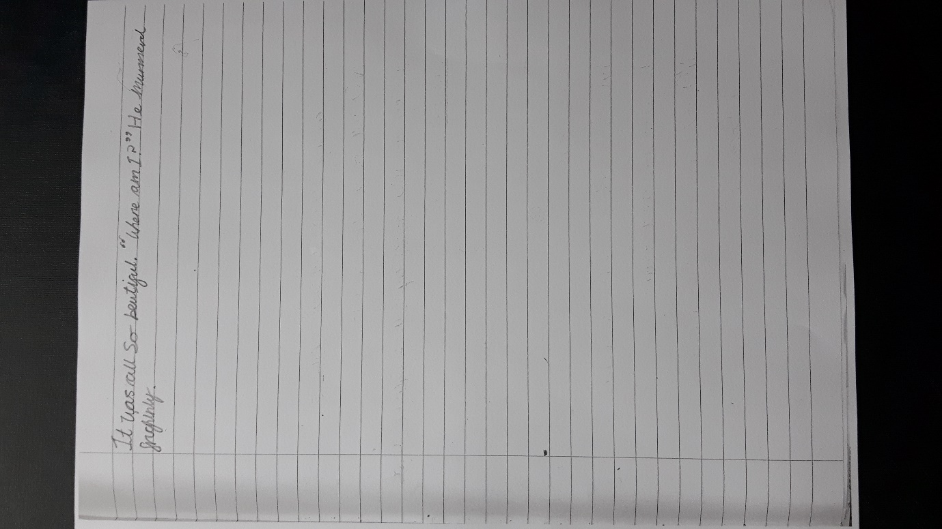
Evidence of level: use of conjuctions, adverbs and propositions.
Next steps: to spell words that are often mis-spelt

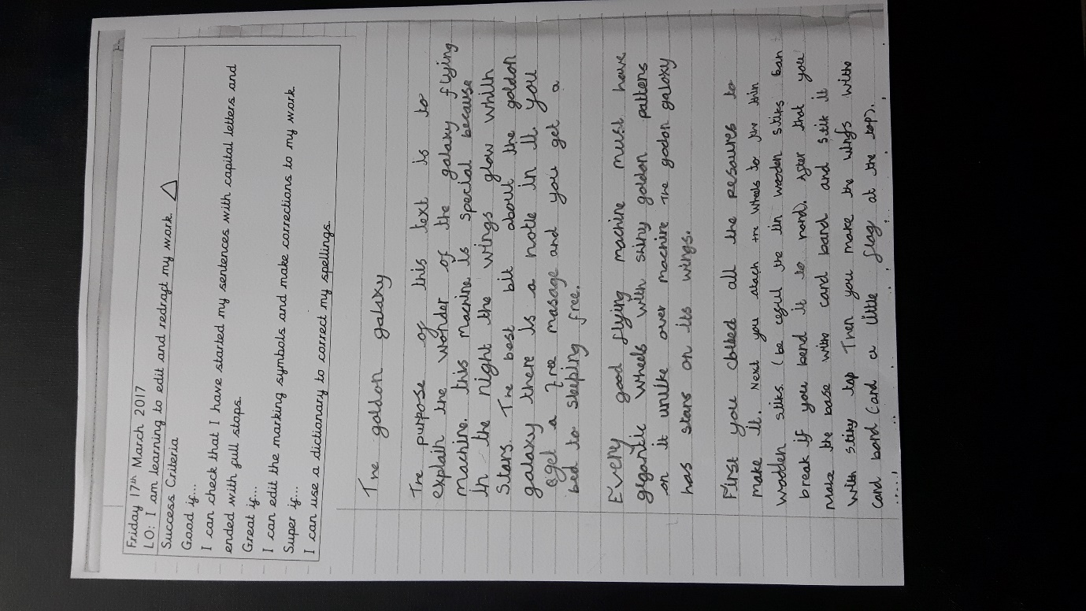
Evidence of level: choosing appropriate nouns and pronouns for clarity.
Next steps: handwriting and spelling of common words
Evidence of level: using the present and perfect form of verbs
Next steps: extending the range of sentences with more than one clause b using a wider range of conjunctions.

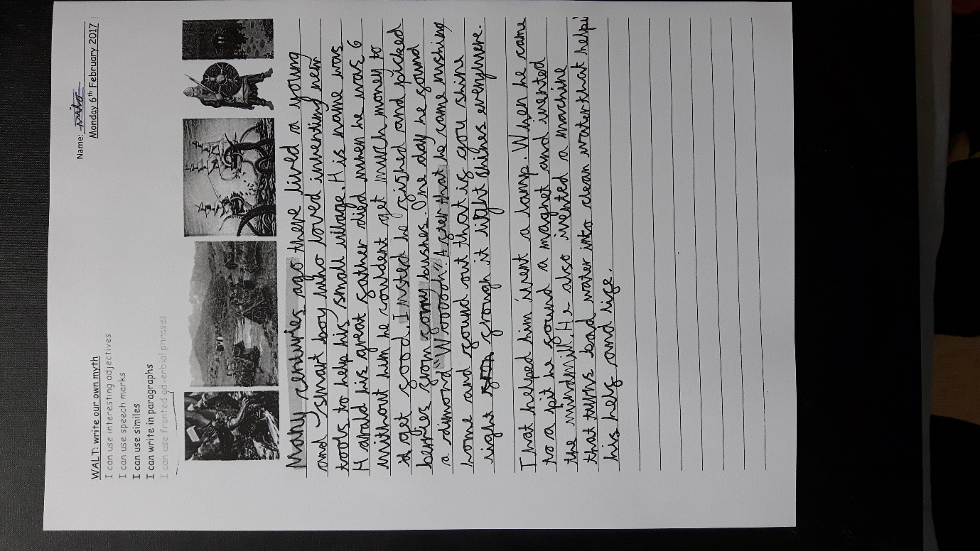
Evidence of level: good character descriptions, tenses, paragraphs and handwriting
Next steps: apostrophes and over all variety

