BLC writing moderations for year 3
Examples of work at age related expectations
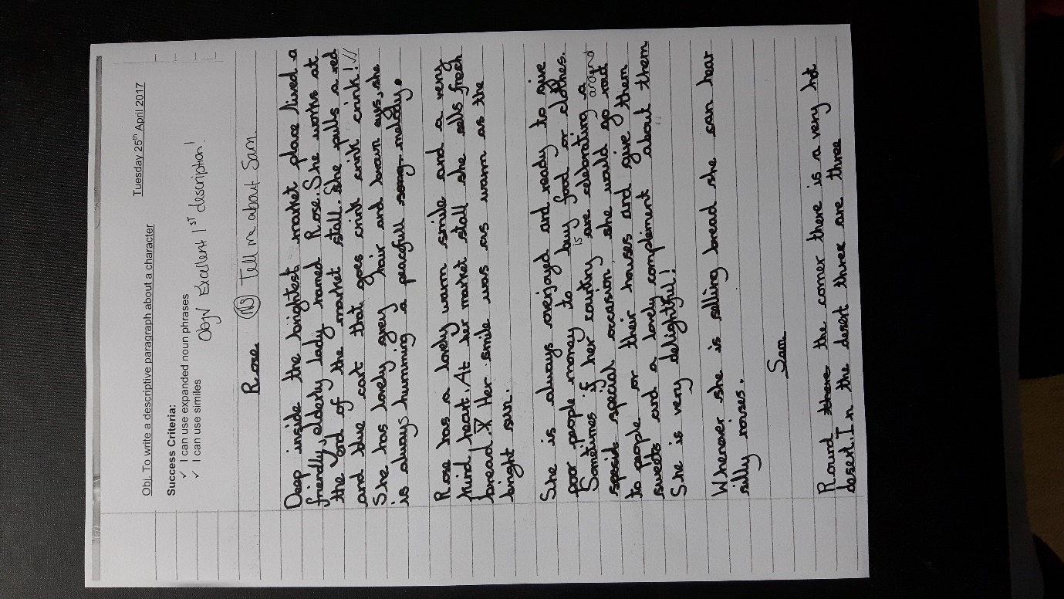
Evidence of level: Fronted adverbials, commas, paragraphs and direct speech
Next steps: apostrophes.

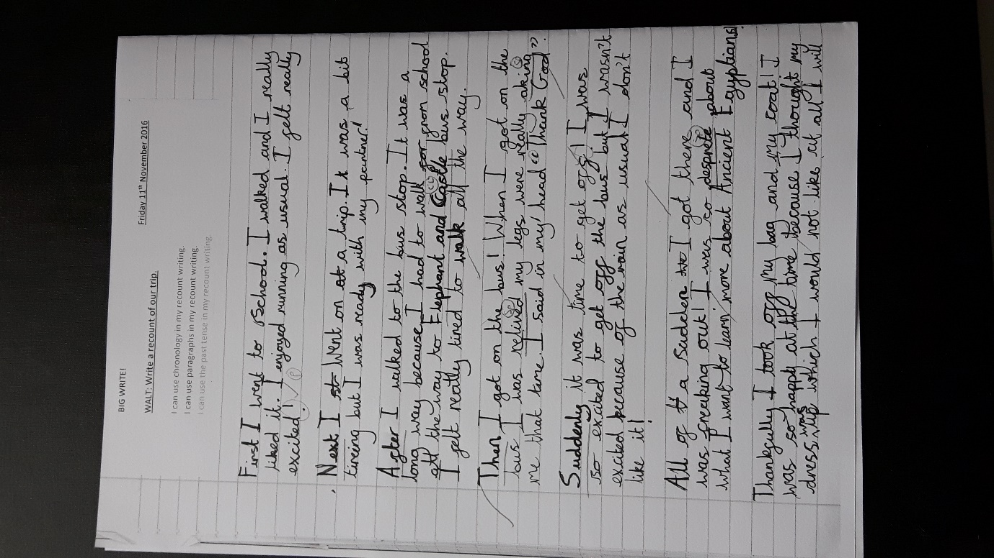
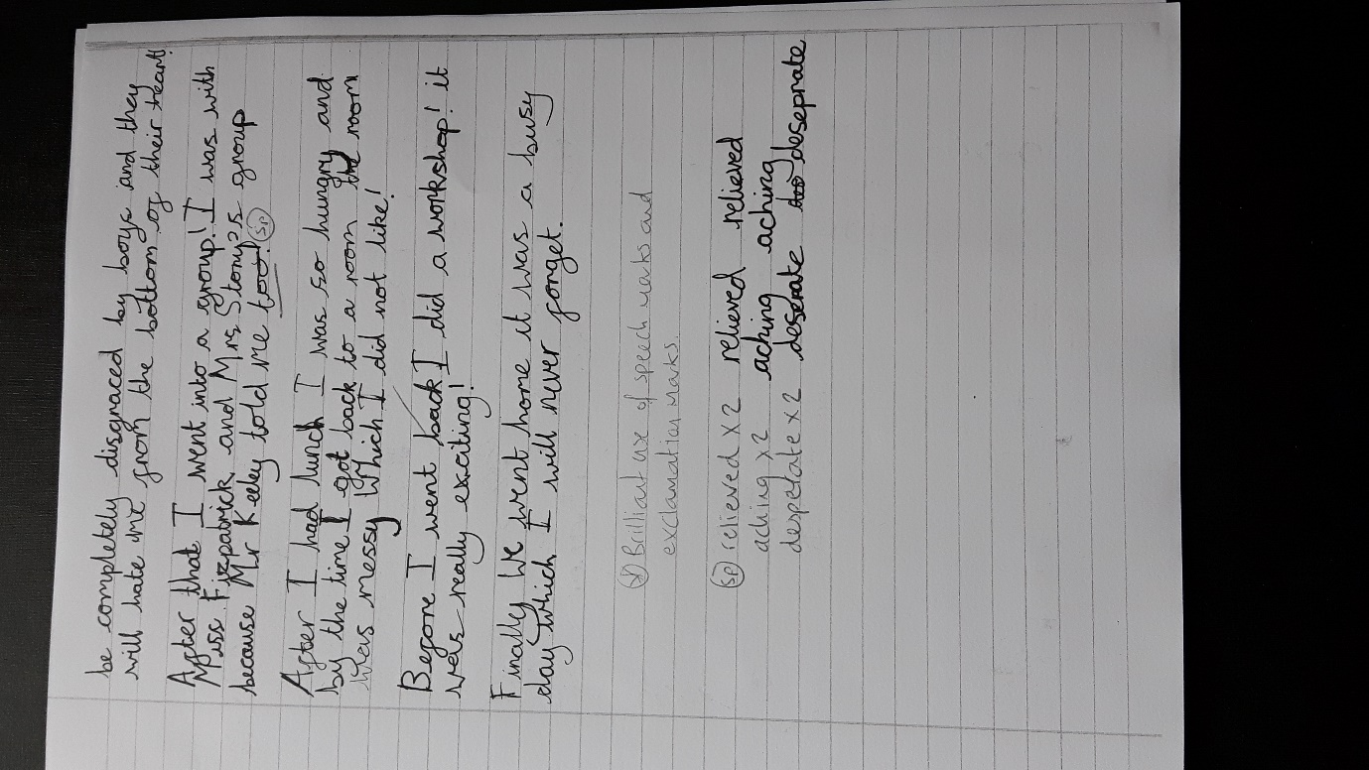
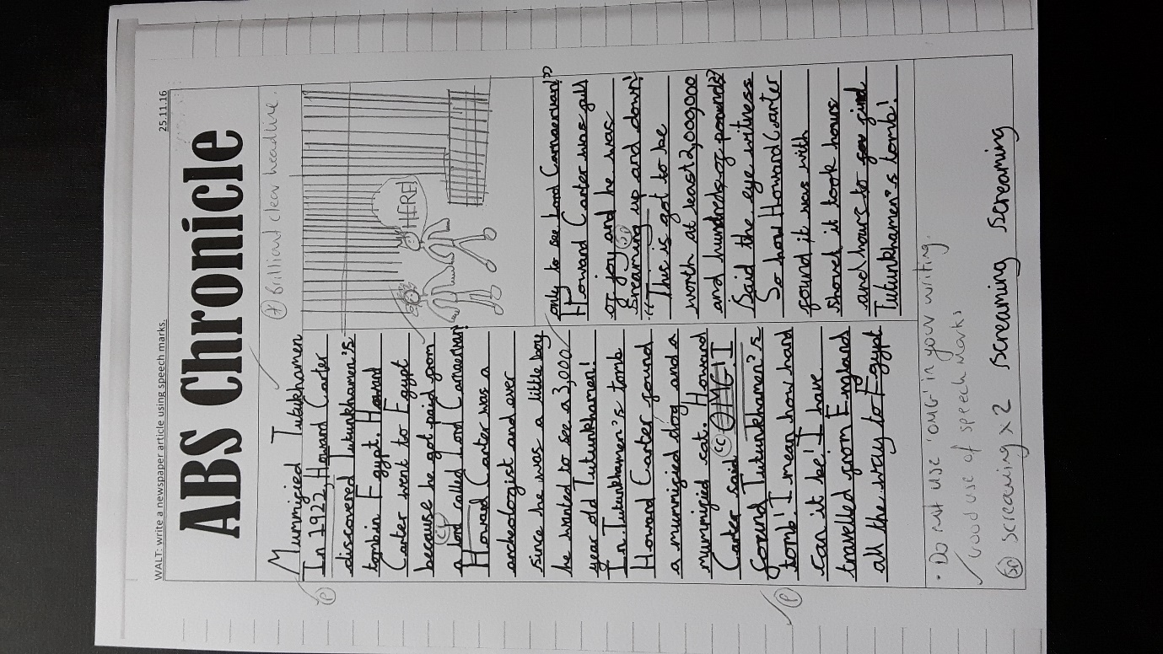

Evidence of level: paragraphs, aliteration, writing for a range of purposes, playscrips and letters
Next steps: embedded use of commas, use of adverbials, prepositional phrases
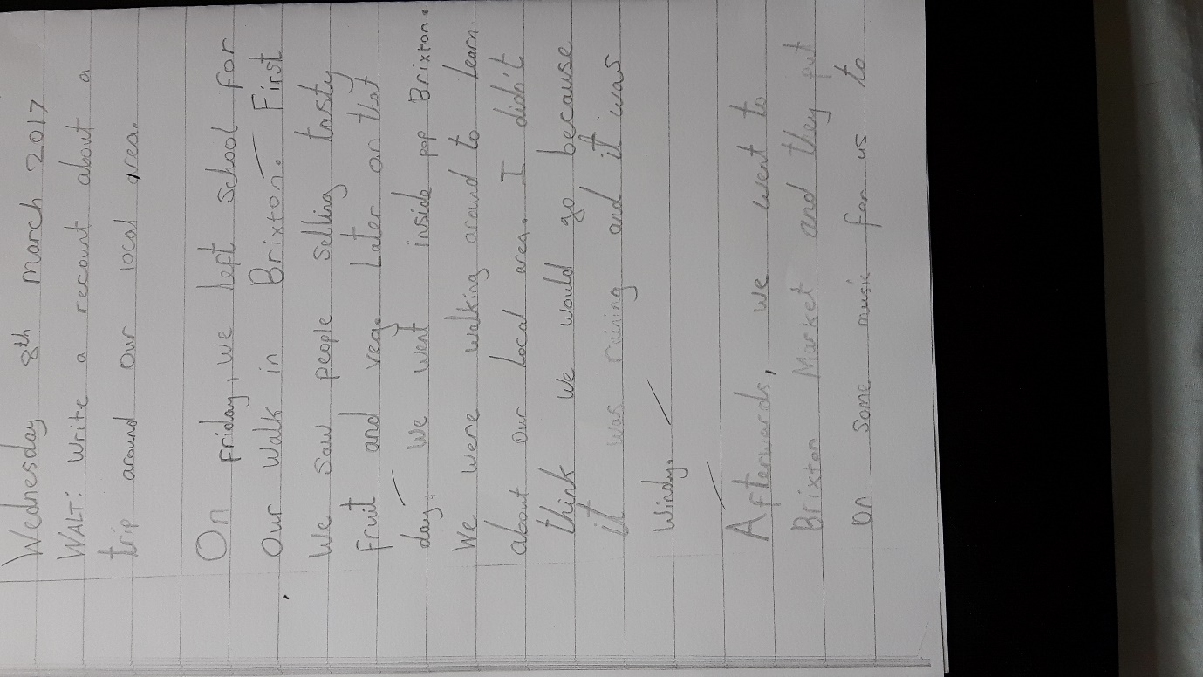

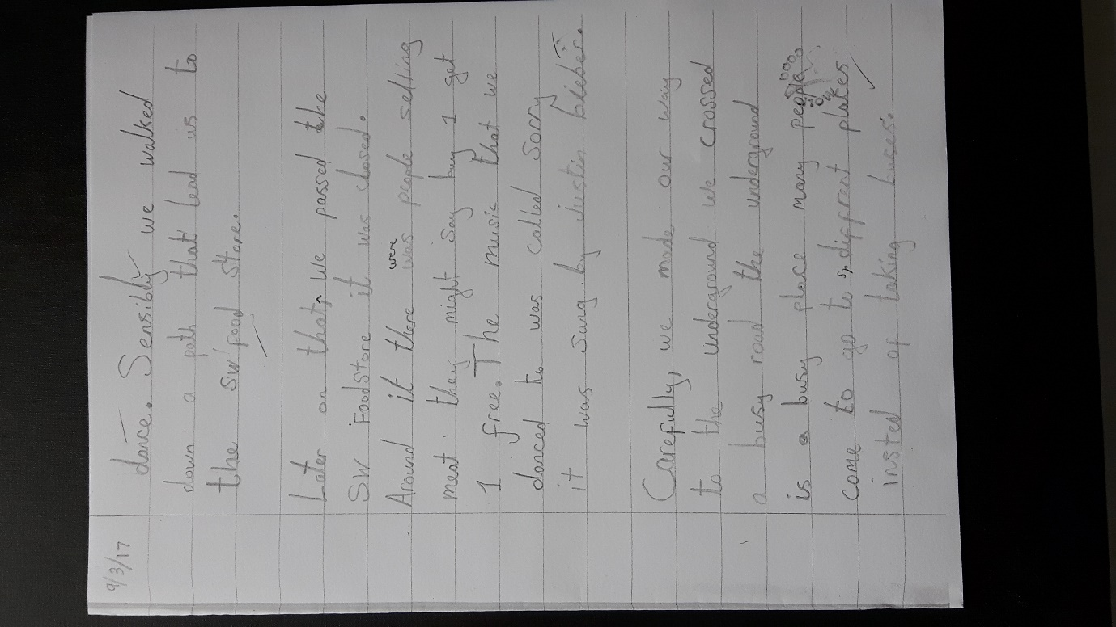

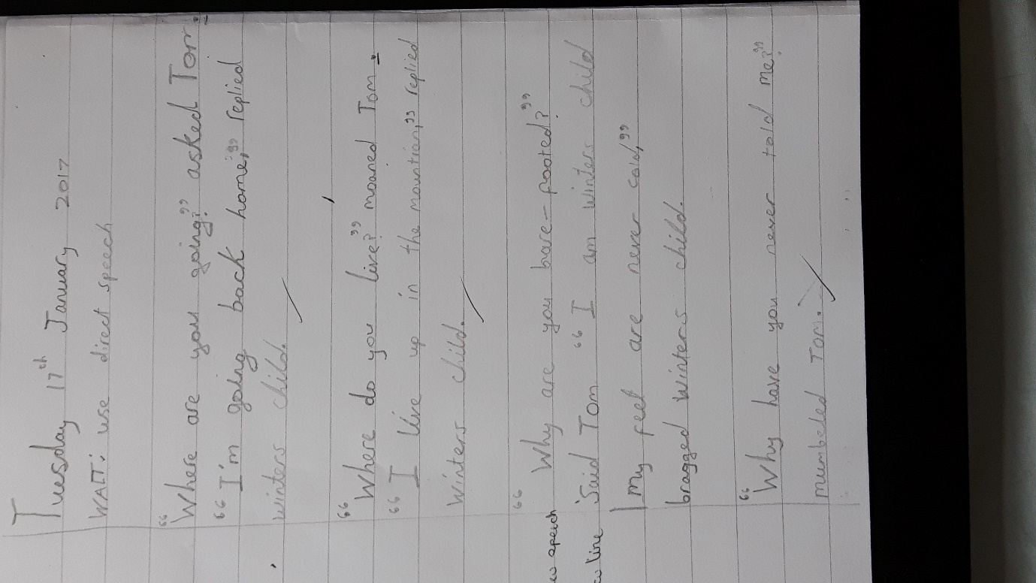

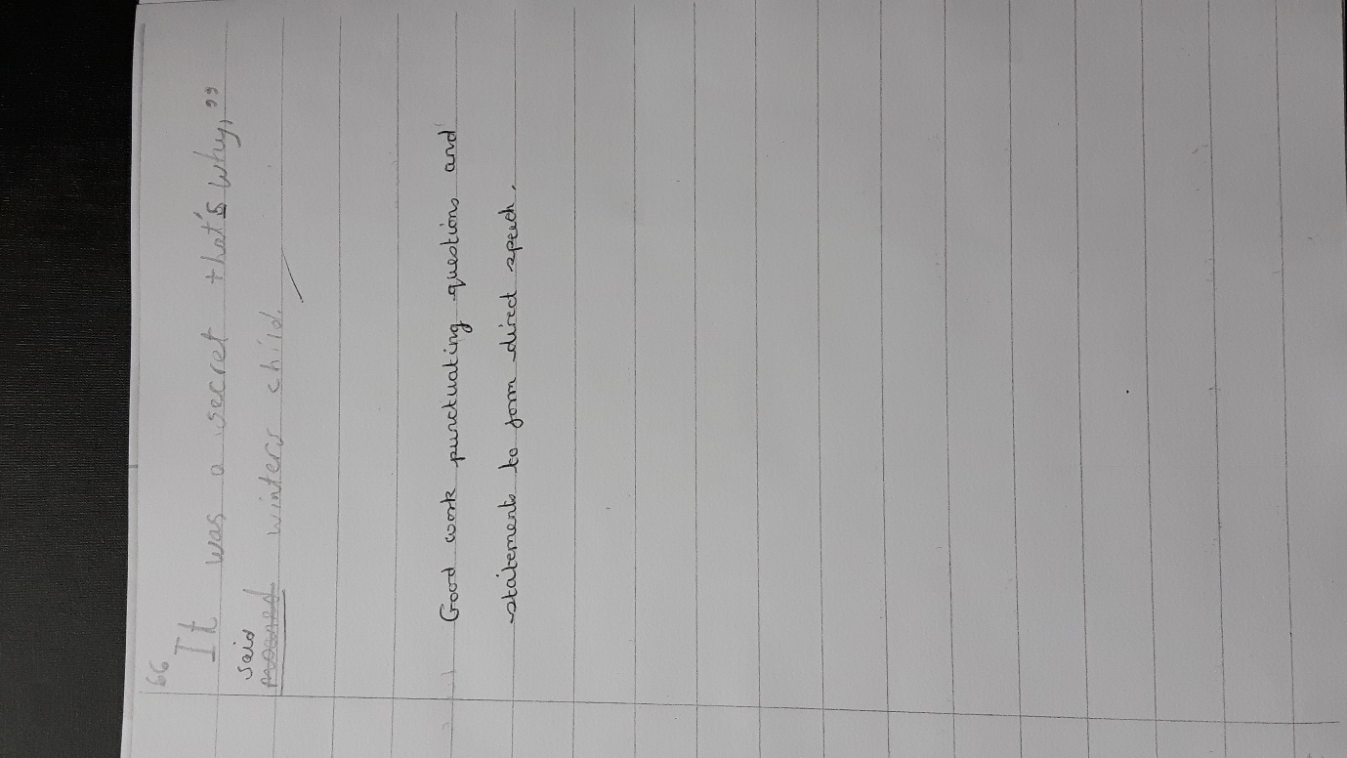
Evidence of level: Descriptive adjectives, commas when listing, use of direct speech, paragraphs
Next steps: punctuation speech with exclamation and question marks etc. use of dictionary to self correct spelling, consistency of handwriting.

Example of exceeding expectation:

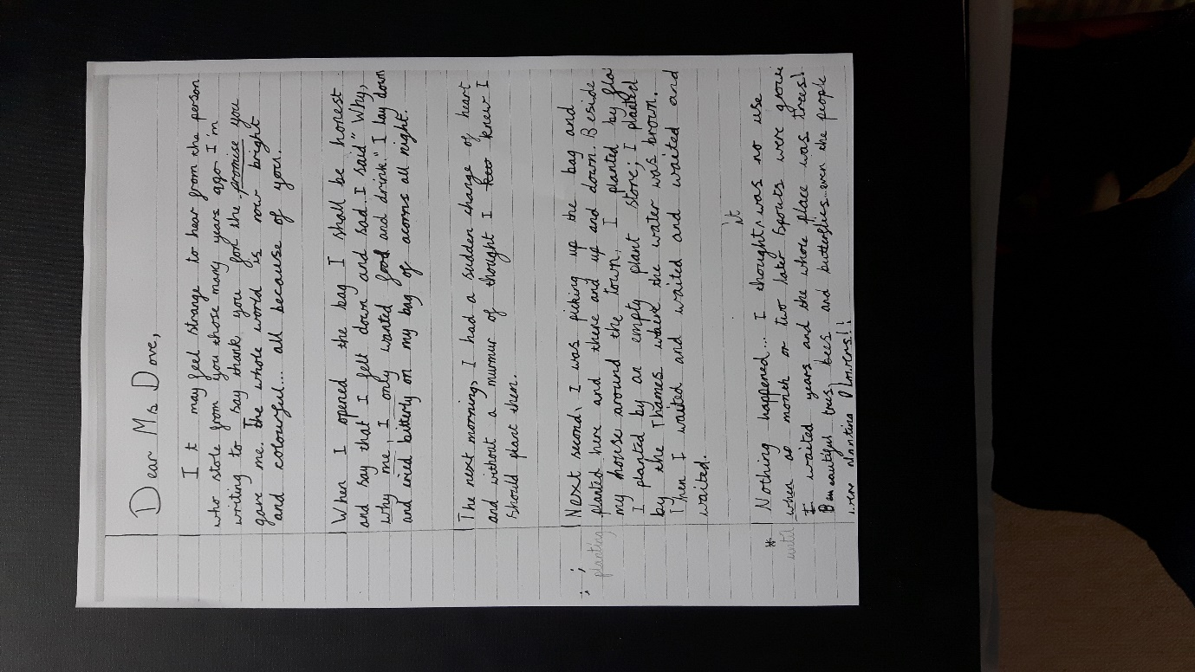
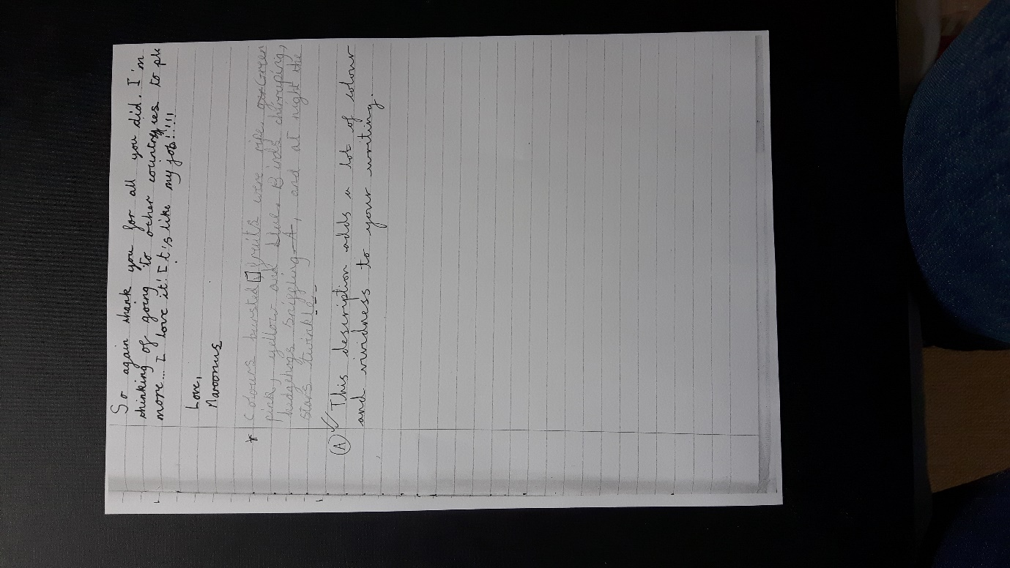
Evidence of level: apstrophes, speech marks, adjectives and fronted adverbials.
Next steps: adverbs
Exceeding:
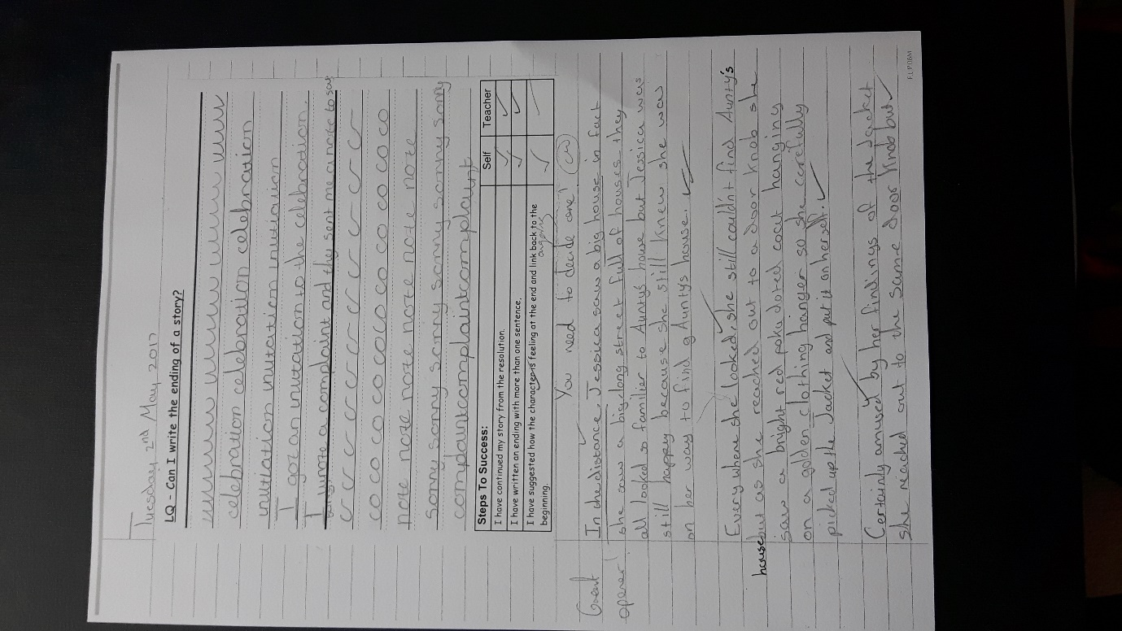

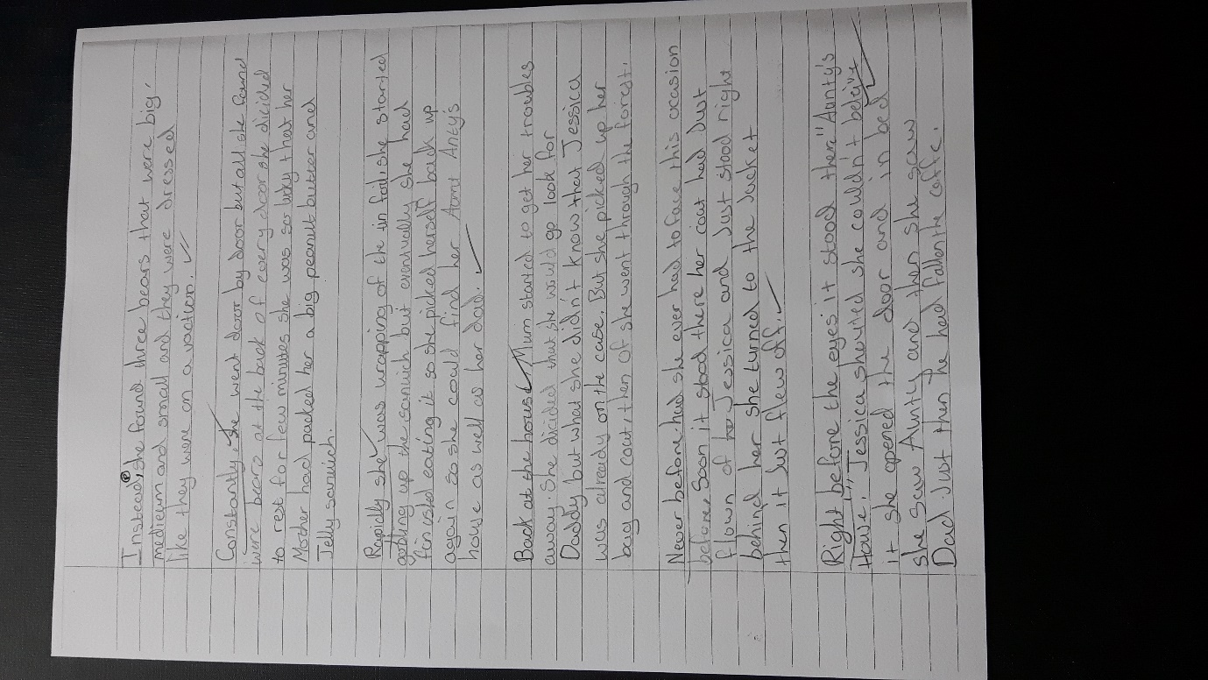
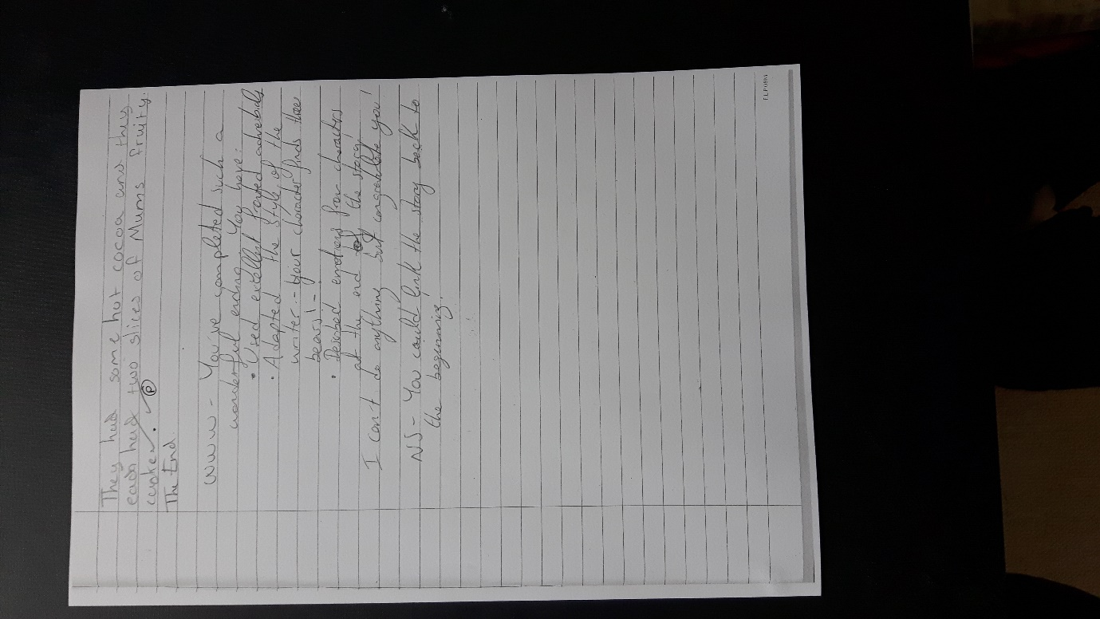
Evidence of level: sentence starters, fronted adverbials, speech marks, comparatives, edits independently, fronted adverbials
Next steps: looking at year 4 curriculum

